# Expert Month-End Application User Guide

## Overview

### 1.1.1 About Expert

Expert is a leading company based in South Africa, specializing in facilitating seamless transactions between dealers and vendors. With a commitment to efficiency and transparency, Expert serves as the trusted intermediary, streamlining the business processes involved in these transactions.

### 1.1.2 Business Processes

In the dynamic landscape of business transactions, Expert plays a pivotal role as the intermediary connecting dealers and vendors. The core business process involves the capturing of transactions between the dealer and the vendor, with Expert acting as the central hub for communication and coordination.

**Key business processes:**

1. **Transaction Capture:**

The “Month End” application is designed to capture transactions between the dealer and the vendor. This ensures accurate and timely recording of all financial interactions.

1. **Middle-Man Facilitation:**

Expert serves as the middle man in the transactional process, facilitation communication and collaboration between the dealer and the vendor. This role enhances efficiency and reduces potential communication gaps.

1. **Remittance Procedures:**

* **Dealers to Expert:**

The application provides a streamlined process for capturing remittances from dealers to Expert. This ensures transparent and traceable financial transactions, contributing to the overall efficiency of the payment process.

* **Expert to Vendors:**

Additionally, the “Month End” application facilitates the remittance process from Expert to vendors. This feature allows for seamless financial transactions between Expert and vendors, contributing to a transparent and accountable financial ecosystem.

### 1.1.3 Importance of the “Month End” Application

The primary purpose of the “Month End” application is to enhance the efficiency of financial processes, specifically focusing on transactions between dealers and vendors. This guide will walk you through the installation, setup, and utilization of the application, ensuring that you can leverage its features to streamline month-end activities.

### 1.2 System Requirements

Before you begin using the “Month End” application, please ensure that your system meets the following requirements:

* **Operating System:** Windows 7 or later.
* **Processor:** Intel Core i5 or equivalent.
* **RAM:** 4GB
* **Disk Space:** 10GB

### 1.3 How to use this guide:

This user guide is structured to guide you through the entire process of using the “Month End” application. Please follow the sections in order to get the most out of the guide:

1. **Introduction:** Youa re currently reading the introduction, which provides you with an overview of the application.
2. **Getting Started:** Learn how to install and set up the “Month End” Application’s user interface.
3. **User Interface:** Familiarize yourself with the key elements of the application’s user interface.
4. **Main Features:** Explore detailed instructions on using each major feature of the application.
5. **Advanced Functionality:** If you are an advanced user, find instructions for more intricate tasks.
6. **Troubleshooting:** Discover solutions to common issues and error messages.
7. **FAQs:** Review frequently asked questions for quick answers.
8. **Support:** Find contact information for customer support and additional resources

Now, let’s get started with the installation and setup of the “Month End” application!

## 2. Getting Started

### Installation Instructions:

1. After receiving the complete zip folder from a trusted employee or administrator. Right click on the compressed folder. You will be prompted with the following:

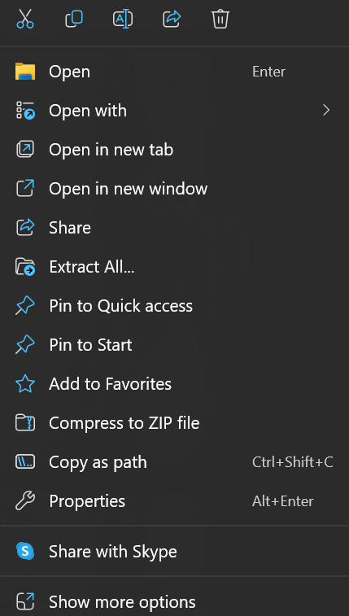

1. A screenshot of a computer

   Description automatically generatedSelect the “Extract All” options. Thereafter you will be prompted with the following window:

1. Choose a destination of your choice where you want to install the application and click on the “Extract” button.
2. After the extraction of the folder completed, double click on the “MonthEnd” folder. You will thereafter see different files of the application showed in the following snapshot:

1. Double click on the ISERMonthend.exe file. (If prompted with the following screen, click on the “More info” link.)

1. Choose the “Run anyway option”.

1. After selecting “Run Anyway” you will be prompted with the following screen:

1. Use the credentials provided to you from an Expert Administrator or staff member to sign into the system.

Please note: If you are prompted with the following screen, your public IP was not registered on the system and assistance needs to be provided from system administrators to assign you to the system to gain access.

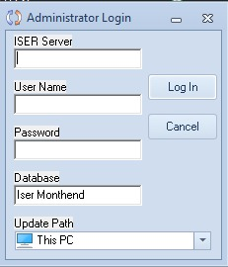

## User Interface

The user interface of the “Month End” application is designed to provide a user-friendly and intuitive experience. Familiarize yourself with the key elements outlined below to navigate and utilize the application efficiently. The application consists of different sections such as1. Running of month-end procedure 2. Import of data, 3. Processing, 4. Cash Flow, and 5. Enquiries. Each section will be discussed in the following subsections.

### How to navigate to the Running of Month -End procedure button:

1. Open the “Month-End.exe” file located on your local device. You will be prompted with the following screen:

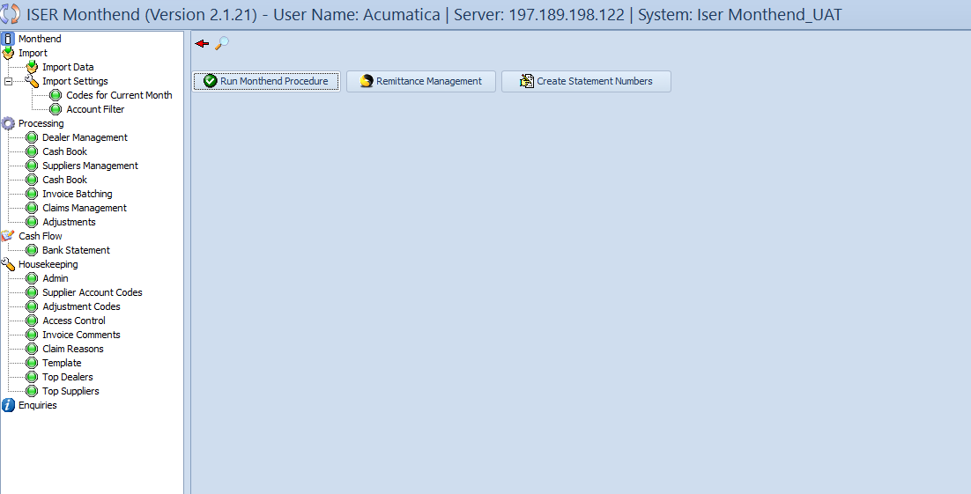\

1. Considering the different views located on your left, you can see all the above mentioned sections and their business processes that will be discussed in more detail later in this guide.

Select the “Monthend” view that is located at the top of the list :



1. After selecting this view you will see 3 different buttons located inside of the view. 1. Run Monthend Procedure, 2. Remittance Management, 3. Create Statement Numbers.

### Running of month-end procedure

The “Running of Month-End Procedure” section is a critical aspect of the “Month-end” application, encompassing essential functionalities to ensure a smooth month-end process. This section comprises three primary buttons:

1. **Run Month-End Procedure**

Clicking the “Run Month-End Procedure” button initiates the automated process of finalizing and consolidating month-end transactions. This button triggers the following actions:

* **Transaction Finalization:** Completes the processing of pending transactions.
* **Data Consolidation:** Aggregates financial data for accurate month-end reporting.
* **Report Generation:** Automatically generates month-end reports for review.

1. **Remittance Manager**

The “Remittance Manager” button provides access to a centralized hub for managing remittances. Key features include:

* **Dealers to Expert Remittance:** Capture remittances from dealers to Expert seamlessly.
* **Expert to Vendors Remittance:** Process payments to vendors efficiently.
* **Remittance History:** View a comprehensive history of all remittances.

1. **Create Statement Numbers**

The “Create Statement Numbers” button is instrumental in assigning unique statement numbers to transactions. This functionality aids in:

* **Transaction Tracking:** Enables the tracking of transactions using unique statement numbers.
* **Audit Trail:** Facilitates an organized audit trail for month-end activities.
* **Transaction Identification:** Enhances the identification and retrieval of specific transactions.

### Additional Tips:

* **Sequence of Execution:** It is recommended to follow a logical sequence by first running the month-end procedure, managing remittances, and then creating statement numbers.
* **Confirmation Prompts:** Be attentive to any confirmation prompts that may appear during these processes. Confirmations may include finalizing transactions or confirming remittances.

By using these buttons, you can efficiently execute crucial month-end tasks, ensuring accuracy, transparency, and compliance with financial processes.

### Import View

### Import Data Subsection.

The “Import Data” subsection withing the “Import” section of the “Month End” application allows users to efficiently import critical data for processing month-end activities. This section is divided into two main subviews: “Import Dealer” and “Import Account”.

**4.1.1 Import Dealer**

The “Import Dealer” subview facilitates the import of dealer-specific data. Here are the key components:

1. **Select Dealer for Import Grid:**

The grid displays relevant information, including:

* **Dealer Ref:** Unique reference identifier for each dealer.
* **Dealer:** Name of the dealer.
* **Locked:** Indicates whether the dealer is locked.
* **Partial Lock:** Indicates partial locking status.
* **Import:** Checkbox for selecting dealers for import.

1. **Import Dealers Button:**

Clicking this button initiates the import process for the selected dealers.

**4.1.2 Import Account**

The “Import Account” subview focuses on the import of account-related data. Components include:

1. **Dropdown List for Dealers:** A dropdown list to select the dealer for which accounts will be imported.
2. **Select Account for Import Grid:**

This grid displays relevant information including:

* + **Supplier Ref:** Reference identifier for the supplier.
  + **Account:** Account code.
  + **Account Description:** Description of the account.
  + **Locked:** Indicates whether the account is locked.
  + **Import:** Checkbox for selecting accounts for import.

1. **Import Accounts Button:**

Clicking this button initiates the import process for the selected accounts.

**4.1.3 Import Details**

* **Invoice Date (Day/Month/Year format):** Displays the invoice date in the day/month/year format.
* **Current Month Items (Day/Month/Year format):** Displays the current month items in the day/month/year format.
* **Show All Users Checkbox:** Check this box to display data for all users.
* **Refresh Button:** Click the refresh button to update the displayed data.

**4.1.4 Subview interaction**

* **Navigating Between Subviews:** Use the tabs to switch between the “Import Dealer” and “Import Account” subviews.
* **Import Dealer and import Account Buttons:** These buttons navigate directly to the respective subviews.

### 4.1.2 Import Settings

This form is at the current time unavailable and not applicable to be in use.

### Processing View

The “Processing” view within the “Month End” application is a comprehensive workspace designed to manage various critical business processes seamlessly. This view is instrumental in streamlining month-end activities and ensuring the accuracy of financial transactions. It consists of different subviews , each dedicated to specific functionalities and processes. The primary subviews include:

1. **Dealer Management:** This subview focuses on the efficient management of dealer-related tasks. It encompasses features related to dealer transactions, status monitoring, and overall dealer performance.
2. **Cashbook(Dealers):** The “Cashbook(Dealers)” subview provides a centralized location for managing financial transactions related to dealers. It includes features for recording dealer payments, maintaining an organized record of cash flow, and monitoring financial transactions specific to dealers.
3. **Suppliers Management:** The “Suppliers Management” subview is dedicated to handling tasks related to suppliers. It includes features for managing supplier transactions, monitoring supplier status, and evaluating overall performance.
4. **Cashbook(Suppliers):** The “Cashbook(Suppliers)” subview focuses on managing financial transactions related to suppliers. It includes features for recording supplier payments, maintaining an organized record of cash flow, and monitoring financial transactions specific to suppliers.
5. **Invoice Batching:** In the “Invoice Batching” subview, users can batch and process invoices, ensuring a systematic and efficient approach to handling billing and invoicing activities.
6. **Claims Management:** The “Claims Management” subview provides tools for making necessary adjustments to financial transactions, ensuring that any discrepancies are addressed and corrected effectively.

Within each subview, users will find specific subsections tailored to address different aspects of the corresponding business processes. This modular approach enhances user experience and allows for focused attention on individual tasks.

Navigate through each subview to leverage the specialized functionalities offered, contributing to a streamlined and effective month-end processing experience.

### Dealer Management

* + - 1. **Dealer Management -Transactions**

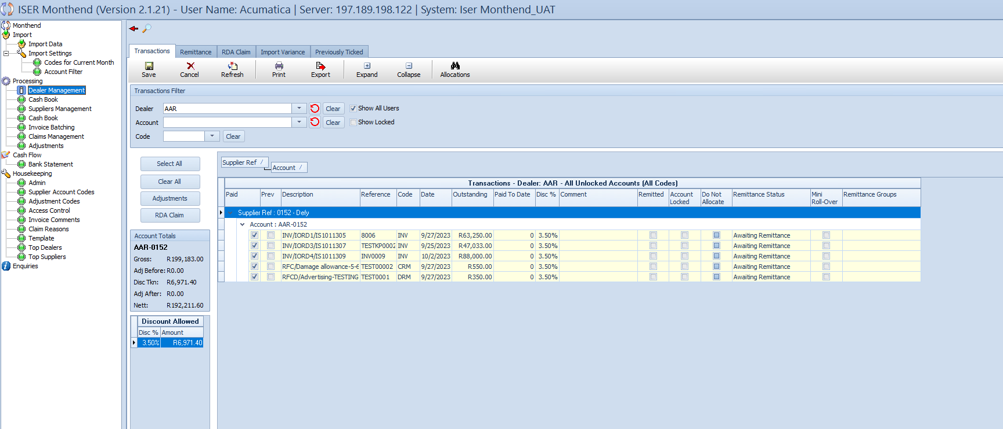

The “Transactions” subview within the “Dealer Management” view is designed to manage and display transactions specific to the selected dealer. This subview comprises a user-friendly interface with several key components:

**Transactions Filter Grid:**

* **Dealer Dropdown:** Use the dropdown to select the specific dealer for whom you want to view transactions.
* **Account Dropdown:** Choose an account from the dropdown to filter transactions by account.
* **Code Dropdown:** Select a code associated with the dealer to further refrine the transaction list.
* **Show All Users Checkbox:** Check this box to display all the dealers in the dropdown, enabling you to select any dealer for viewing transactions.
* **Refresh Button:** Click the refresh button to update the page based on the selected dealer, account, and code.

**Transactions Output Table:**

* **Table Heading:** Transactions – Dealer: (Name of dealer - All Unlocked Accounts (All codes)
* **Table Columns:**

1. Paid (Checkbox)
2. Prev(Checkbox)
3. Description
4. Reference
5. Code
6. Date
7. Outstanding
8. Paid to Date
9. Disc%
10. Comment
11. Remitted(Checkbox)
12. Account Locked(Checkbox)
13. Do Not Allocate(Checkbox)
14. Remittance Status
15. Mini Roll-Over(Checkbox)
16. Remittance Groups

**Transaction Table Buttons**

* **Select All:** Click this button to select all transactions in the table,
* **Clear All:** Click this button to clear the selction of all transactions.
* **Adjustments:** Click this button to make adjustments to the selected transactions.
* **RDA Claims:** Click this button to initiate an RDA (Retail Development Allowance) claim for the selected transactions.

**Account Totals Grid**

* **Grid Heading:** Displays the Dealer account code
* **Grid Columns:**

1. Gross
2. Adjustments Before
3. Discounts Taken
4. Adjustments After
5. Net total

**Discount Allowed Table**

* **Table Heading:** Discount Allowed
* **Table Columns:**

1. **Disc% (Discount Percentage)**
2. **Amount**

**Interacting with the table**

* **Paid(Checkbox):** Indicate items that are to be paid by checking the “Paid” checkbox.
* **Selecting and Clearing:** Use the “Select all” and “Clear all” buttons for efficient selection parameters.
  + - 1. **A screenshot of a computer

         Description automatically generatedDealer Management – Remittance**

The “Remittance” subview within the “Dealer Management” view focuses on handling remittance details for each dealer. This subview comprises essential components for efficient management.

**Transactions Filter Grid**

* **Dealer Dropdown:** Select the specific dealer for whom you want to manage remittance transactions.
* **Period of Remittance Dropdown:** Choose the period for remittance from the dropdown.
* **Show All Users Checkbox:** Check this box to display all dealers in the dropdown, enabling selection for remittance.
* **Show Locked Checkbox:** Check this box to display locked transactions in the “Remittance Transactions” table.
* **Select Transactions Button:** Click this button to select remitted transactions based on the chosen criteria.

**Remittance Transactions Table**

* **Table Columns:**

1. Collected
2. Date
3. Code
4. Reference
5. Description
6. Debit
7. Credit
8. Outstanding

**Account Totals Grid**

* **Grid Columns:**

1. Gross
2. Discount
3. Discount Amount
4. Credits
5. Payment Due

**Interacting with the subview**

* **Dealer and Period Selection:** Utilize the dropdowns to choose the dealer and period of remittance.
* **Show All Users Checkbox:** Ensure this box is checked to display all dealers for selection.
* **Show Locked Checkbox:** Check this box to include locked transactions in the remittance process.
* **Select Transactions Button:** Click to choose remitted transactions based on selected criteria.
* **Remittance Transactions Table:** Display collected, date, code, reference, description, debit, credit, and outstanding data fields.
* **Account Totals Grid:** Presents Gross, discount, discount amount, credits, and payment due for the selected period.
  + - 1. **Dealer Management -RDA Claim**

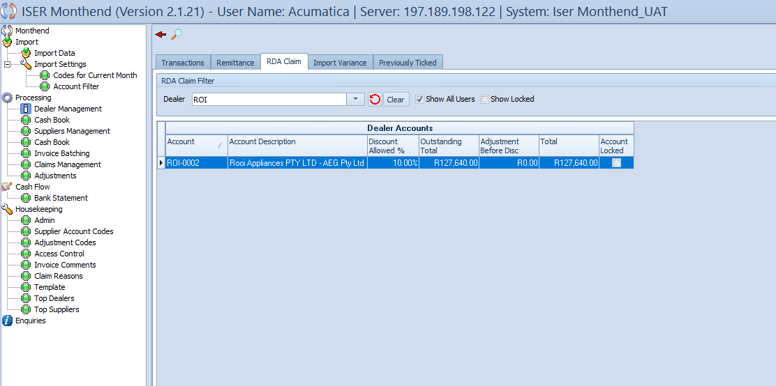

The “RDA Claim” subview within the “Dealer Management” view provides an overview of all the claims made. This subview consists of key components for effective management:

**RDA Claim Filter Grid:**

* **Dealer Dropdown:** Select the specific dealer for whom you want to view RDA Claims.
* **Show All Users Checkbox:** Check this box to display all dealers in the dropdown, enabling selection for RDA claims.
* **Show Locked Checkbox:** Check this box to include locked claims in the output tables.

**Dealer Accounts Table:**

* **Table Columns:**

1. Account
2. Account Description
3. Discount Allowed
4. Outstanding Total
5. Adjustment Before Disc
6. Total
7. Account Locked(Checkbox)

**RDA Claim Table**

* **Table Columns:**

1. Outstanding
2. Remittance Code
3. Adjustment Before Discount
4. Discount Allowed %
5. Discount Taken %
6. Discount Amount Taken

* **Table Heading:** RDA Claim – Account: [Account code] – Discount Allowed: [Discount Allowed % in the Dealer Accounts Table].

**Interacting with the Subview**

* **Dealer Selection:** Choose the dealer for whom you want to view RDA claims from the dropdown.
* **Show All Users Checkbox:** Ensure this box is checked do display RDA claims selection
* **Show Locked Checkbox:** Explore this box to include locked claims in the output tables.
  + - 1. **Dealer Management – Import Variance**

This is view is not currently used and only displays the difference between previous and current imported data.

* + - 1. **Dealer Management – Previously Ticked**

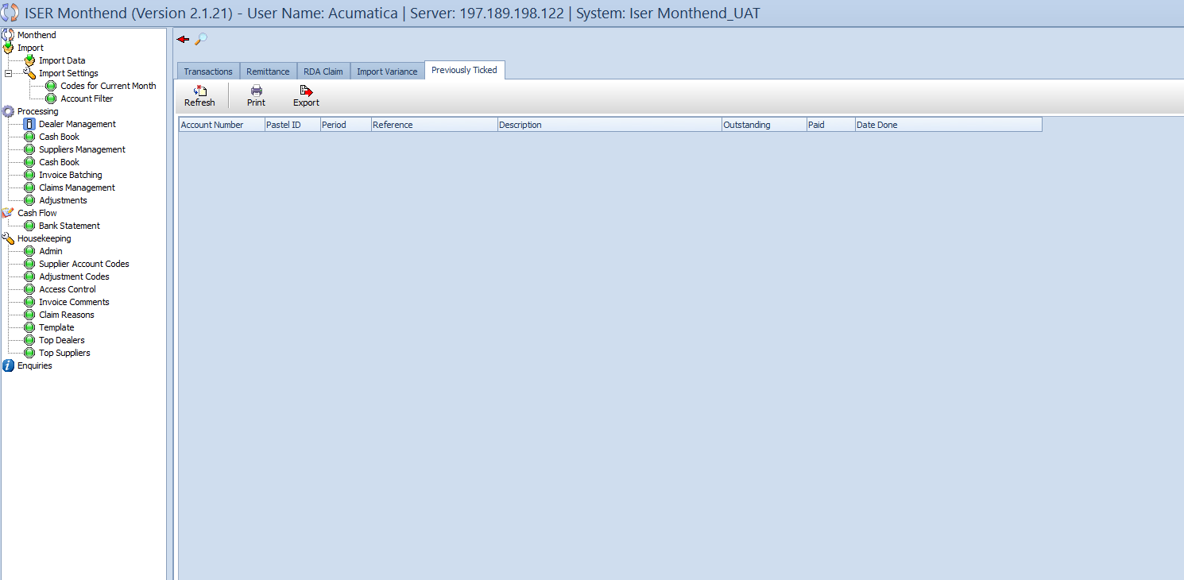

The “Previously Ticked” subview within the “Dealer Management” view displays transactions that have been marked or ticked for reporting purposes. This subview comprises essential components for efficient management:

**Output Table:**

* **Table Columns:**

1. Account Number
2. Pastel ID
3. Period
4. Reference
5. Description
6. Outstanding
7. Paid
8. Date Done

* **Action Buttons**

1. **Refresh Button:** Click this button to refresh the table output for record-keeping or reporting.
2. **Print Button:** Use the Print button to print the output for record-keeping or reporting.
3. **Export Button:** Click the Export button to export the data for further analysis or external use.

**Interacting with the subview**

* **Table Data:** The table displays information about previously ticked transactions, including account number, pastel ID, period, reference, description, outstanding amount, paid amount, and the date the transaction was marked.

### Cashbook (Dealers)

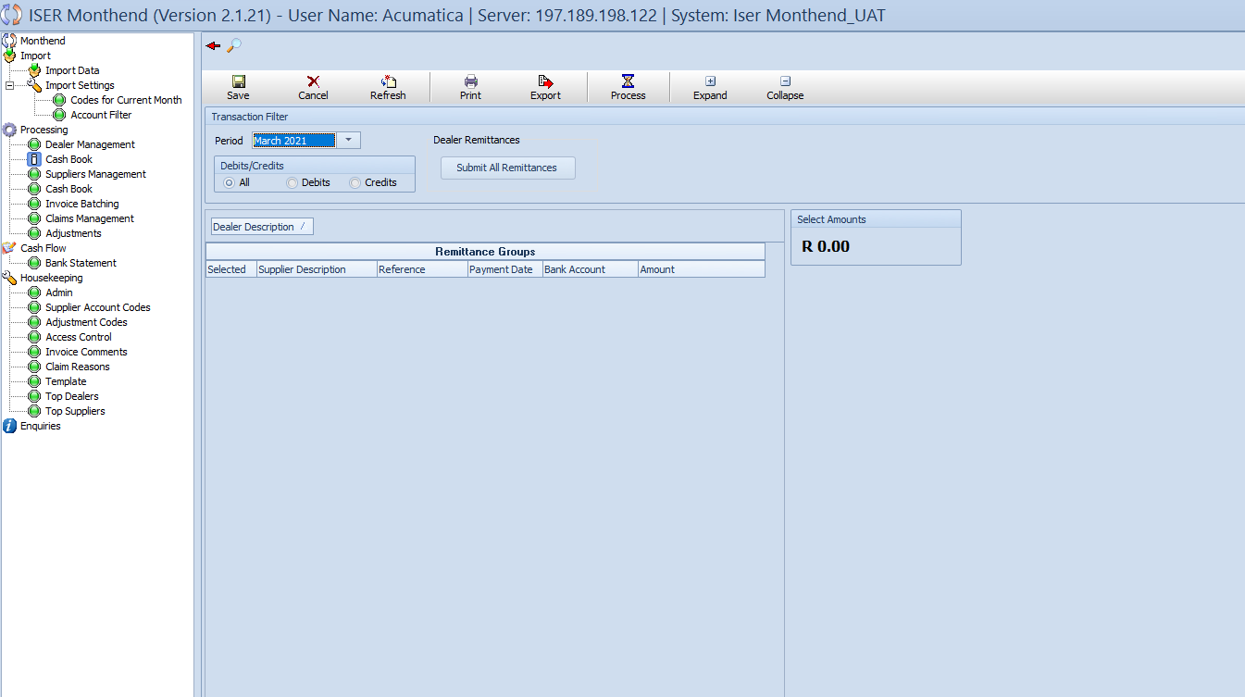

The “Cashbook” subview within the “Processing View” is dedicated to managing the cashbook for dealers, handling remittances from different dealers, and overseeing Dealer to Expert Remittances. This subview consists of key components for effective management:

**Top Grid:**

* **Buttons:**

1. **Save:** Save changes made in the table.
2. **Cancel:** Cancel the changes and revert to the previous state.
3. **Refresh:** Update the data displayed in the Remittance Groups table.
4. **Print:** Print the displayed data for record-keeping.
5. **Export:** Export the data for external analysis.
6. **Process:** Process the selected remittances.
7. **Expand:** Expand the view to display more detail.
8. **Collapse:** Collapse the view to provide a concise overview.

**Transaction Filter Grid:**

* **Date Interval Dropdown:** Choose from different intervals of dates for filtering transactions.
* **Debits/Credits/All Single Selection Combobox:** Select either Debits, Credits, or All to filter the transactions accordingly.
* **Submit All Remittances Button:** Click to submit ticked remittances.

**Remittance Groups Table:**

* **Table Header:** Remittance Groups
* **Table Columns:**

1. Selected
2. Supplier Description
3. Reference
4. Payment Date
5. Bank Account
6. Amount

**Amount Output Grid**

* **Selected Amounts of Remittances:** Displays the total amount of the selected remittances.

**Interacting with the subview:**

* **Top Grid Buttons:** Utilize the Save, Cancel, Refresh, Print, Export, Process, Expand, and Collapse buttons for various operations.
* **Transaction Filter:** Choose the date interval and transaction type to filter the displayed transactions
* **Submit All Remittances Button:** Submit ticked remittances with this button.
* **Remittance Groups Table:** View and manage remittances from different dealers.
* **Amount Output:** Observe the total amount of the selected remittances.

### Processing View- Suppliers Management

* + - 1. **Processing View – Suppliers Management - Transactions**

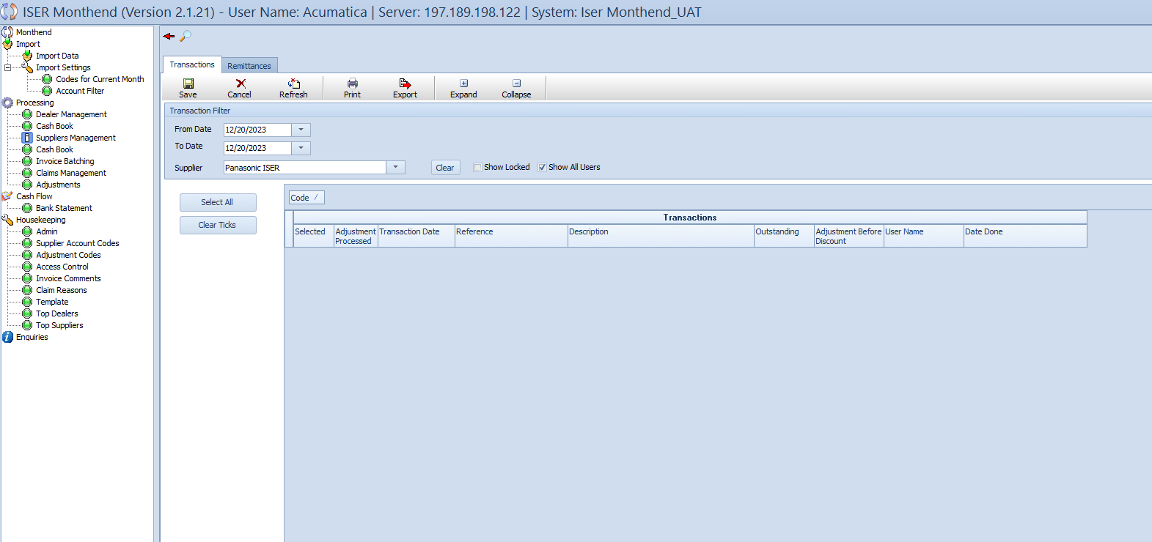

The “Transactions” subview within the “Suppliers Management” view is designed to manage transactions for suppliers. This subview consists of two main components: The top grid and the transactions table.

**Top Grid:**

* **Buttons:**

1. **Save:** Save changes made in the grid and the table.
2. **Cancel:** Cancel the changes and revert to the previous state.
3. **Refresh:** Update the data displayed in the Transactions Table.
4. **Print:** Print the displayed data for record-keeping.
5. **Export:** Export the data for external analysis.
6. **Expand:** Expand the view to display more details.
7. **Collapse:** Collapse the view to provide a concise overview.

**Transaction Filter Grid:**

* **Date Interval Dropdowns:** Choose a time interval with “From Date” and “To Date” dropdowns for filtering transactions.
* **Supplier Dropdown:** Select a supplier from the dropdown to filter transactions for that supplier.
* **Clear Button:** Clear the selected supplier to reset the filter.
* **Show Locked Checkbox:** Check this box to display locked transactions in the Transactions Table.
* **Show All Users:** Check this box to display transactions for all users.

**Transactions Table:**

* **Table Columns:**

1. Selected.
2. Adjustment Processed
3. Transaction Date
4. Reference
5. Description
6. Outstanding
7. Adjustment Before Discount
8. User Name
9. Date Done

**Action Buttons:**

* **Select All:** Click this button to select all transactions in the table.
* **Clear Ticks:** Click this button to clear the selection of all transactions.

**Interacting with the subview**

* **Top Grid Buttons:** Utilize the Save, Cancel, Refresh, Print, Export, Expand, and Collapse buttons for various operations.
* **Transaction Filter:** Choose the date interval, supplier and other options to filter transactions.
* **Transactions Table:** View and manage supplier transactions. Including adjustment processing details.
* **Select All and Clear Ticks Buttons:** Efficiently manage the selection of transactions.
  + - 1. **Processing View – Suppliers Management – Remittance**

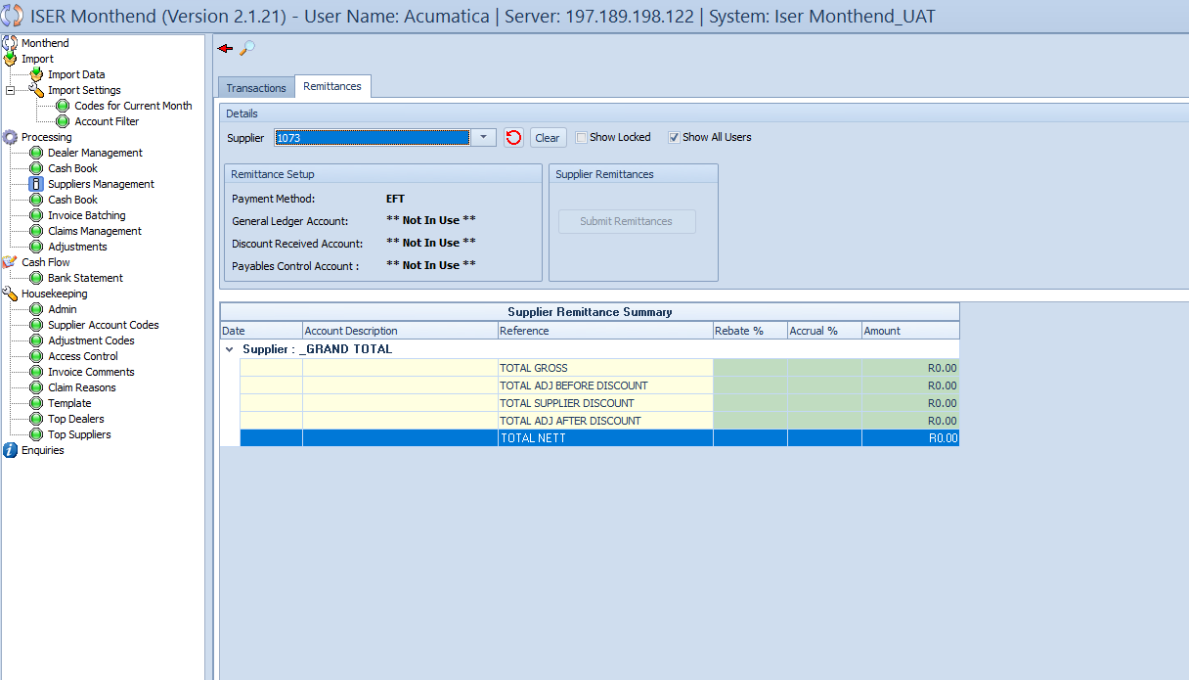

The “Remittance” subview within the “Suppliers Management” view is designed to handle remittances for suppliers. This subview consists of several components, including the “Details” Grid, “Remittance Setup” grid, and the “Supplier Remittance Summary” output table.

**Details Grid**

* **Supplier dropdown:** Select a supplier from the dropdown to manage remittances for that supplier.
* **Refresh Button:** Click this button to refresh the supplier dropdown list.
* **Clear button:** Clear the selected supplier and reset the filter.
* **Show Locked Checkbox:** Check this box to display locked remittances in the Supplier Remittance Summary table.
* **Show All Users Checkbox:** Check this box to display remittances for all users.

**Remittance Setup Grid**

* **Textboxes:** Display information retrieved from the database, including:

1. Payment method
2. General Ledger Account
3. Discount Received
4. Payables Control Account

**Supplier Remittances Grid**

* **Submit Remittances Button:** Click this button to submit remittances for the selected supplier.

**Supplier Remittance Summary table:**

* **Table Columns:**

1. Date
2. Account Description
3. Reference
4. Rebate %
5. Accrual %
6. Amount

**Interacting with the subview**

* **Details Grid:**  Choose the supplier, refresh the dropdown, clear selections, and apply filter options.
* **Remittance Setup Grid:** View essential details related to remittance setup for the selected supplier.
* **Supplier Remittances Grid:** Submit remittances for the selected supplier.
* **Supplier Remittance Summary Table:** View and analyze the summary of supplier remittances.

### Processing View – Cashbook(Suppliers)

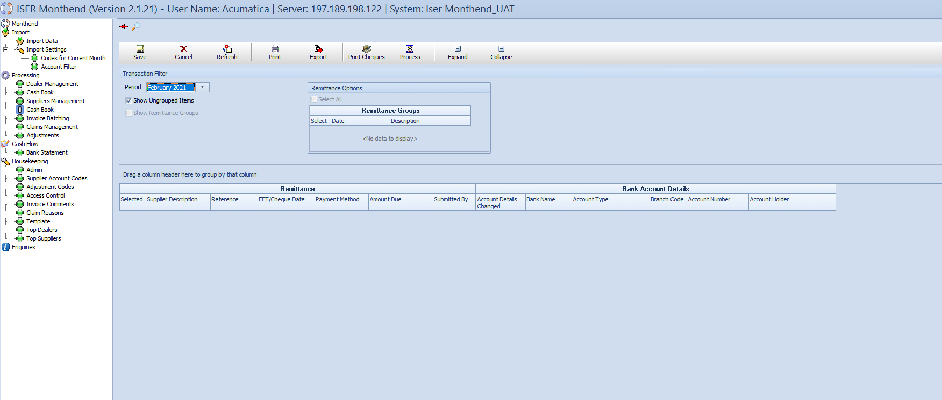

The “Cashbook(Suppliers)” subview within the “Processing View” is dedicated to managing the cashbook for suppliers. This subview mirrors the functionality of the Cashbook(Dealers) view and consists of several key components, including the “Transaction Filter” grid, “Remittance options” grid, and various output tables.

**Transactions Filter Grid**

* **Month Period Dropdown:** Choose the month period for which the month-end processing is being done.
* **Show Ungrouped Items Checkbox:** Check this box to display ungrouped items.

**Remittance Options Grid**

* **Remittance Group Table Columns:**

1. Select
2. Date
3. Description

**Output Tables**

* **Remittance Table columns:**

1. Selected
2. Supplier Description
3. Reference
4. EFT/Cheque Date
5. Payment Method
6. Amount Due
7. Submitted By

* **Bank Account Details Table columns:**

1. Account Details Changed
2. Bank Name
3. Account Type
4. Branch Code
5. Account Number
6. Account Holder

* **Cheques Table**

1. Checked
2. Cheque Number
3. Cheque Date
4. Account Description
5. Amount

**Interacting with the subview**

* **Transactions Filter grid:** Choose the month period and configure additional options.
* **Remittance Options grid:** View available remittance groups.
* **Output Tables:** View and manage remittance details, bank account information, and cheques.

### A screenshot of a computerProcessing – Claims Management

The “Claims Management” subview within the “Processing” view is dedicated to handling claims from suppliers to dealers. This subview comprises several key components., including the “Transactions Filter” grid and the “Transactions” output table.

**Transactions Filter Grid:**

* **Period Dropdown:** Choose the period for which the claims are being managed.
* **Import All Claims button:** Click to import all claims.
* **Supplier dropdown:** Select a supplier to filter claims for that specific supplier
* **Dealer dropdown:** Choose a dealer to filter claims for that specific dealer.

**Output table – Transactions**

* **Columns:**

1. Apply To Supplier
2. Valid
3. Before Discount
4. Supplier
5. Dealer
6. Claims Controller
7. Date
8. Reference
9. Description
10. Amount
11. Invoice Number
12. Credit Note Number
13. Authorization
14. Claim Reason

**Action Buttons:**

* **Save:** Save changes made in the grid.
* **Refresh:** Update the data displayed in the Transactions Table.
* **Print:** Print the displayed data for record-keeping.
* **Export:** Export the data for external analysis.
* **Expand:** Expand the view to display more details.
* **Collapse:** Collapse the view to provide a concise overview

**Interacting with the subview**

* **Transaction Filter grid:** Choose the period, import claims, and filter claims based on the selected supplier and dealer.
* **Transactions table:** View and manage claim details, including supplier, dealer, date, reference, description, amount, and more.
* **Action buttons:** Utilize the Save, Refresh, Print, Export, Expand, and Collapse buttons for various operations.

### Processing View – Adjustments – Dealers

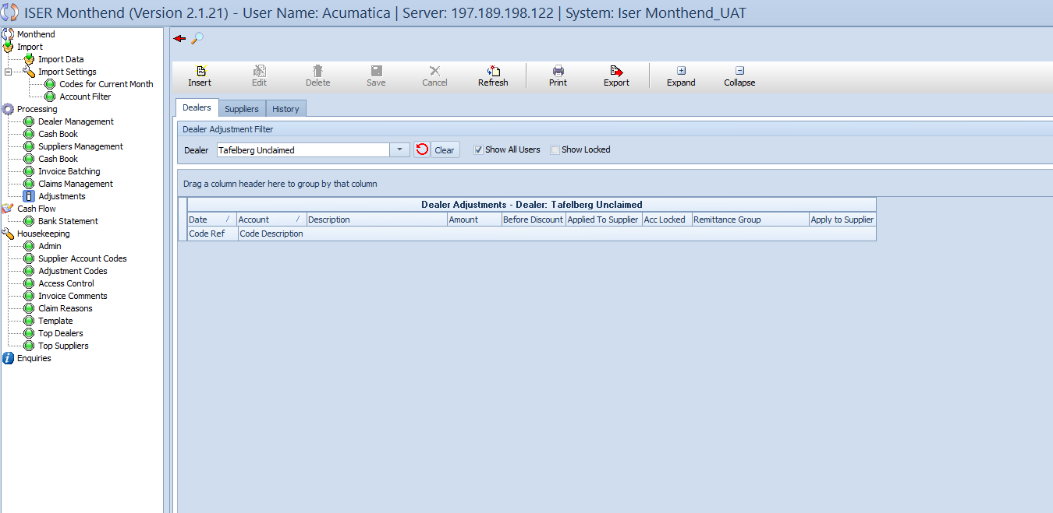

The “Adjustments – Dealers” subview within the “Processing” view is designed to manage adjustments for dealers. This subview comprises several key components, including the “Dealer Adjustment Filter” grid and the “Dealer Adjustments” output table.

**Dealer Adjustment Filter grid**

* **Dealer dropdown:** Choose a dealer for whom adjustments are being managed.
* **Refresh button:** Click to refresh the dealer dropdown list.
* **Clear button:** Clear the selected dealer and reset the filter.
* **Show All Users button:** Display all the users in the dropdown list.
* **Show Locked button:** Display locked users.

**Dealer Adjustments output table**

* **Columns:**

1. Date
2. Dealer
3. Account
4. Description
5. Amount
6. Before Discount
7. Applied To Supplier
8. Acc Locked
9. Remittance Group
10. Apply To Supplier
11. Code Ref
12. Code Description

**Action Buttons**

* **Insert:** Insert a new adjustment record.
* **Edit:** Edit the adjustment record.
* **Delete:** Delete the selected adjustment record.
* **Save:** Save changes made in the grid.
* **Cancel:** Cancel the changes and revert to the previous state.
* **Refresh:** Update the data displayed in the Dealer Adjustments table.
* **Print:** Print the displayed data for record-keeping.
* **Export:** Export the data for external analysis.
* **Expand:** Expand the view to display more details.
* **Collapse:** Collapse the view to provide a concise overview.

**Interacting with the subview**

* **Dealer Adjustment Filter grid:** Choose the dealer, refresh the dropdown, clear selections, and apply filter options.
* **Dealer Adjustments table:** View and manage dealer adjustments, including date, account, description, amount, and more.
* **Action buttons:** Utilize the Insert, Edit, Delete, Save, Cancel, Refresh, Print, Export, Expand, and Collapse buttons for various operations.

### Processing view – Adjustments – Suppliers

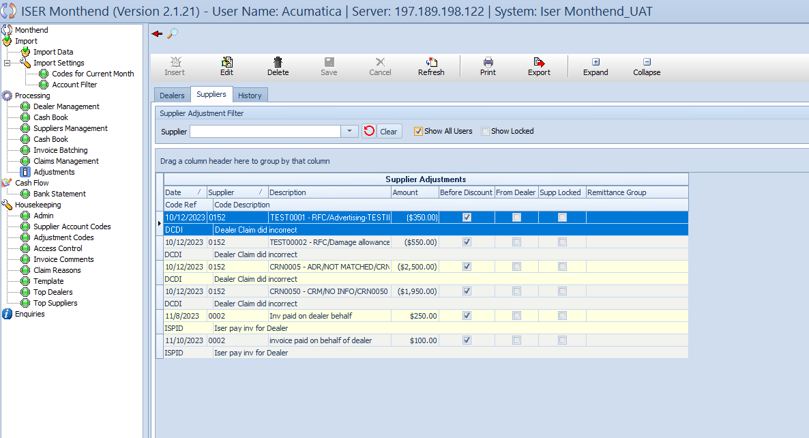

The “Adjustments – Suppliers” subview within the “Processing” view mirrors the structure and functionality of the “Adjustments – Dealers” subview. It is designed to manage adjustments for suppliers. This subview comprises several key components, including the “Supplier Adjustment Filter” grid and the “Supplier Adjustments” and “Dealer Adjustment” output tables.

**Supplier Adjustment Filter grid**

* **Supplier dropdown:** Choose a supplier for whom adjustments are being managed.
* **Refresh Button:** Click the refresh button to refresh the supplier dropdown list.
* **Clear button:** Clear the selected supplier and reset the filter.
* **Show All User checkbox:** Display all users in the dropdown.
* **Show Locked checkbox:** Display locked suppliers.

**Supplier Adjustments output table:**

* **Columns:**

1. Date
2. Supplier
3. Description
4. Amount
5. Before Discount
6. From Dealer
7. Supp Locked
8. Remittance Group
9. Code Ref
10. Code Description

**Dealer Adjustment output table**



* **Columns:**

1. Date
2. Dealer
3. Account
4. Description
5. Amount
6. Before Discount
7. Applied to Supplier
8. Acc Locked
9. Remittance Group
10. Code Ref
11. Code Description

**Action buttons:**

* **Insert:** Insert a new adjustment record
* **Edit:** Edit the selected adjustment record.
* **Delete:** Delete the selected adjustment record.
* **Save:** Save changes made in the grid.
* **Cancel:** Cancel the changes and revert to previous state.
* **Refresh:** Update the data displayed in the Supplier Adjustments table.
* **Print:** Print the displayed data for record-keeping.
* **Export:** Export the data for external analysis.
* **Expand:** Expand the view to display more details.
* **Collapse:** Collapse the view to provide a concise overview.

**Interacting with the subview**

* **Supplier Adjustment filter grid:** Choose the supplier, refresh the dropdown, clear selections, and apply filter options.
* **Supplier Adjustments table:** View and manage supplier adjustments, including date, description, amount, and more.
* **Dealer Adjustments table:** View and manage dealer adjustments related to the selected supplier.
* **Action buttons:** utilize the Insert, Edit, Delete, Save, Cancel, Refresh, Print, Export, Expand, and Collapse buttons for various operations.

### Processing View – Adjustment – History



A screenshot of a computer

The “History” view within the “Adjustments” view allows users to track historical adjustments. This view consists of two subviews: “ Dealers” and “Suppliers”. Each subview has a “Details grid at the top, an output table and sub-columns for detailed information.

* + - 1. **Dealers subview**

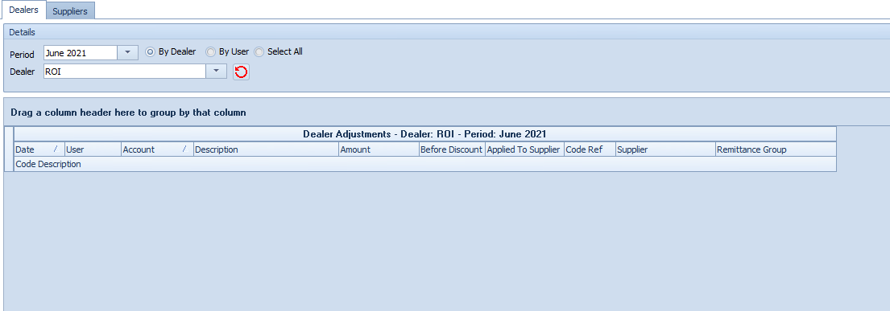

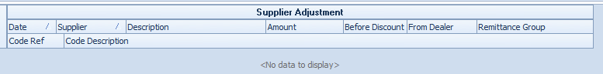

**Details grid**

* **Period dropdown:** Choose the month for historical adjustments.
* **Selection box:** Choose from options: By Dealer, By User, Select All.
* **Dealer Dropdown:** Select a dealer for filtered historical data.
* **Refresh button:** Refresh the dealer dropdown list.

**Dealer Adjustments output table**

* **Columns:**

1. Date
2. User
3. Account
4. Description
5. Amount
6. Before Discount
7. Applied to Supplier
8. Code Ref
9. Supplier
10. Remittance Group
11. Code Description

**Supplier Adjustment output table**

* **Columns:**

1. Date
2. Supplier
3. Description
4. Amount
5. Before Discount
6. From Dealer
7. Remittance Group
8. Code Ref
9. Code Description
   * + 1. **Suppliers subview**

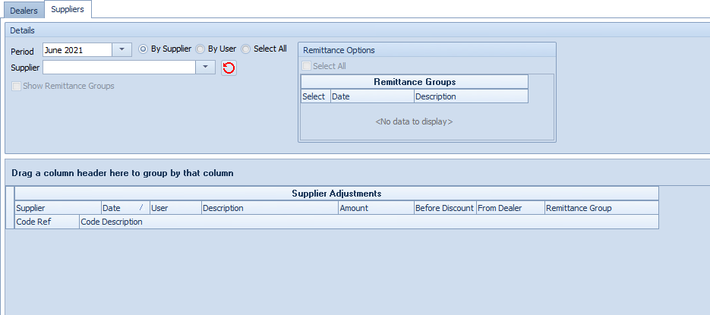

**Details grid**

* **Period dropdown:** Choose the month for historical adjustments.
* **Selection List:** Choose from options: By Supplier, By User, Select All.
* **Supplier dropdown:** Select a supplier for filtered historical data.
* **Refresh button:** Refresh the supplier dropdown list.

**Remittance Options grid**

* **Select All checkbox:** Select all remittance groups.
* **Remittance Group table columns:**

1. Select
2. Date
3. Description

**Supplier Adjustments output table:**

* **Columns:**

1. Supplier
2. Date
3. User
4. Description
5. Amount
6. Before Discount
7. From Dealer
8. Remittance Group
9. Code Ref
10. Code Description

**Dealer Adjustment output table**

* **Columns:**

1. Date
2. Account
3. Description
4. Amount
5. Before Discount
6. Apply To Supplier
7. Remittance Group
8. Code Ref
9. Code Description

**Action Buttons**

* **Insert:** Insert a new historical adjustment record.
* **Edit:** Edit the selected historical adjustment record.
* **Delete:** Delete the selected historical adjustment record.
* **Save:** Save changes made in the grid.
* **Cancel:** Cancel the changes and revert to the previous state.
* **Refresh:** Update the data displayed in the historical adjustments tables.
* **Print:** Print the displayed data for record-keeping.
* **Export:** Export the data for external analysis.
* **Expand:** Expand the view to display more details.
* **Collapse:** Collapse the view to provide a concise overview.

**Interacting with the subview**

* **Details grid:** Choose the period, selection options, and filter data by dealers or suppliers.
* **Output tables:** View and manage historical adjustments for dealers and suppliers.
* **Remittance Options grid:** Select remittance groups for the Suppliers subview.
* **Action buttons:** Utilize the Insert, Edit, Delete, Save, Cancel, Refresh, Print, Export, Expand, and Collapse buttons for various operations.

### Housekeeping Section

**Overview of the section**

The “Housekeeping” section in the Month-End Application is a comprehensive section encompassing various views, including Admin, Supplier Account Codes, Access Control, Invoice Comments, Claim Reasons, Template, Top Dealers, and Top Suppliers. Within these views, users can efficiently manage crucial details related to administrators, supplier account codes, access controls, invoice comments, claim reasons, templates, and gain valuable insights through top dealers and suppliers’ performance metrics. The “Housekeeping” section serves as a centralized management and strategic decision-making across multiple facets of the system.

### Housekeeping – Admin

**Overview of Admin view**

The “Admin” view in the Housekeeping section is a multifaceted module with four distinct subviews: Suppliers, Dealers, Dealer Accounts, and Locking. In the “Suppliers” subview, users can access comprehensive information about suppliers, including details such as email addresses, telephone numbers, brand descriptions, branch codes, and accepted payment methods. The “Dealers” subview provides insights into dealer specifics, showcasing dealer references, names, system suspensions status, and whether the cashbook is remittable. Moving to the “Dealer Accounts’ subview, users can review crucial financial details such as account numbers, account descriptions, supplier references, and default rebate information. The “Locking” subview offers an overview of the locking status between dealers and suppliers, ensuring users can efficiently manage and monitor the business processes that needs to follow.

* + - 1. **A screenshot of a computer

         Description automatically generatedHousekeeping – Admin – Suppliers**

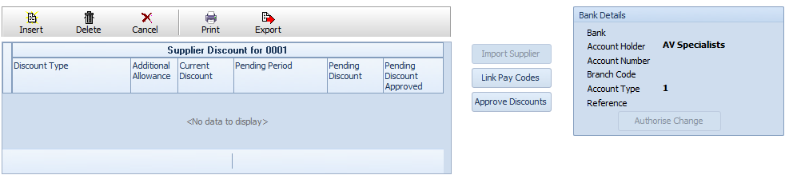

**Overview of Suppliers view**

The “Suppliers” subview within the “Admin” view of the “Housekeeping” section is a powerful tool for managing essential supplier information. Users can effortlessly navigate through different functionalities provided in this subview.

**Main Output Table**

The main output table displays comprehensive details about suppliers, key columns include Supplier Ref, Supplier, Controller, Payable Control, Total Disc, Head Office Contact, Tel, Fax, Brand Description, E-mail, and various checkboxes indicating the supplier’s status (Active, System Suspended, Exists in System). Entries are color-coded for easy identification: Red for suppliers not in the system, yellow for system suspended, White for active, and Grey for deactivated suppliers.

**Supplier Discount Details**

Beneath the main table, the “Supplier Discount for [Supplier Ref]” output table provides insights into Discount Type, Additional Allowance, Current Discount, Pending Period, Pending Discount, and Pending Discount Approved. Users can take advantage of action buttons like Insert, Delete, Cancel, Print, and Export for efficient management.

**Additional Actions**

On the right side of the Supplier Discount table, three buttons-Import Supplier, Link Pay Codes, and Approve Discounts-offer additional functionalities. The “Bank Details” grid displays crucial financial information, including Bank, Account Holder, Account Number, Branch Code, Account Type, and Reference, with an “Authorize Change” button for streamlined authorization processes.

**Interaction and Navigation**

Users can efficiently interact with supplier data through color-coded entries, action buttons, and additional functionalities. The tab section at the top allows seamless navigation between different subviews within the “Admin” view.

* + - 1. 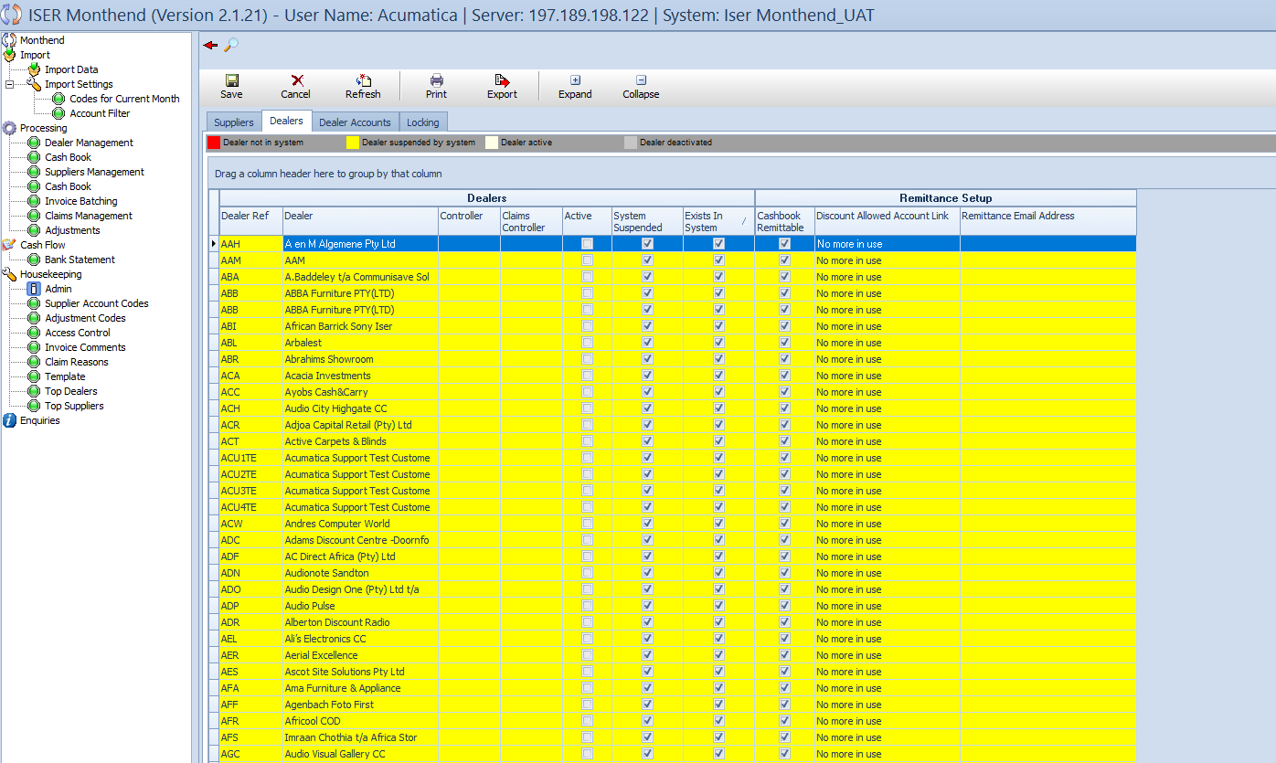**Housekeeping – Admin – Dealers**

**Overview of Housekeeping – Admin – Dealers**

The “Dealers” subview within the “Admin” view of the “Housekeeping” section provides a detailed overview of dealer-related information. Users can efficiently manage and navigate through key details associated with dealers.

**Main Output Table**

The main output table consists of two sections: “Dealers” and “Remittance Setup”.

**Dealers and Remittance Setup Output Table**

* **Columns:**

1. Dealer Ref
2. Dealer
3. Controller
4. Claims Controller
5. Active (checkbox)
6. System Suspended (checkbox)
7. Exists In System (checkbox)
8. Cashbook Remittable (checkbox)
9. Discount Allowed Account Link (no longer in use)
10. Remittance Email Address

* **Entries in the table are color-coded for quick identification**:

1. **Red:** Dealer not in the system.
2. **Yellow:** System-suspended dealer.
3. **White:** Active dealer.
4. **Grey:** Deactivated dealer.

**Importing Dealers**

At the bottom of the view, users can find an “Import Dealer” button, facilitating the streamlined import of dealer-related data.

**Action Buttons**

The action buttons mentioned earlier – Insert, Edit, Delete, Save, Cancel, Refresh, Print, Export, Expand, and Collapse – apply to this subview as well, ensuring users have versatile tools for managing dealer data.

**Interaction and Navigation**

Users can efficiently interact with dealer-related data, leveraging color-coded entries, action buttons, and additional functionalities. The tab section at the top allows seamless navigation between different subviews within the “Admin” view.

* + - 1. **Housekeeping – Admin – Dealer Accounts**

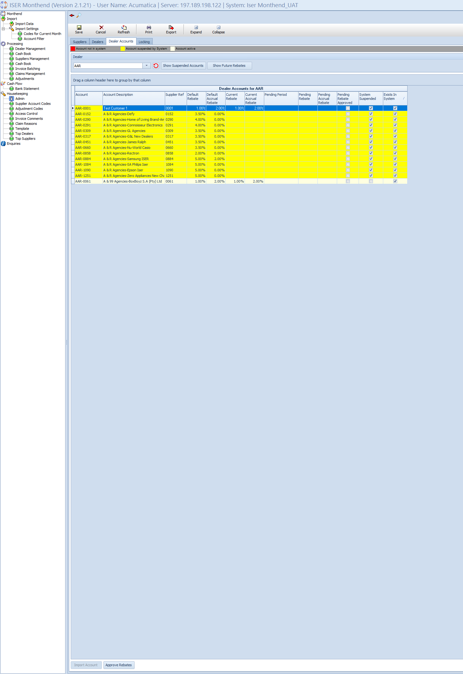

**Overview**

The “Dealer accounts” subview within the “Admin” view of the “Housekeeping” section enables users to manage and navigate through crucial dealer account details. The color schema aids quick identification, with red indicating an account not in the system, yellow for a system-suspended account, and white for an active account.

**Main Output Table – Dealer Accounts for [Dealer]**

* **Columns:**

1. Account
2. Account Description
3. Supplier Ref
4. Default Rebate
5. Pending Period
6. Pending Accrual Rebate
7. Pending Rebate Approved (checkbox)
8. System Suspended (checkbox)
9. Exists In System (checkbox)

**Dealer Grid**

Located below the color schema, the “Dealer” grid offers functionalities for refining data:

* **Dealer Dropdown:** Select a dealer to filter data.
* **Refresh Button:** Update the dealer dropdown list.
* **Show Suspended Accounts Button:** Display suspended accounts.
* **Show Future Rebates Button:** Highlight future rebates.

**Importing Accounts and Rebate Approval**

At the bottom of the view, users can find two buttons for operations:

* **Import Account:** Facilitates the efficient import of dealer accounts.
* **Approve Rebates:** Allows users to approve pending rebates.

**Action Buttons**

The standard action buttons - Insert, Edit, Delete, Save, Cancel, Refresh, Print, Export, Expand, and Collapse – are applicable to this subview, providing users with versatile tools for managing dealer account data.

**Interaction and Navigation.**

Users can efficiently interact with dealer account data, utilizing the color schema, dropdowns, and action buttons. The tab section at the top ensures seamless navigation between different subviews within the “Admin” view.

* + - 1. 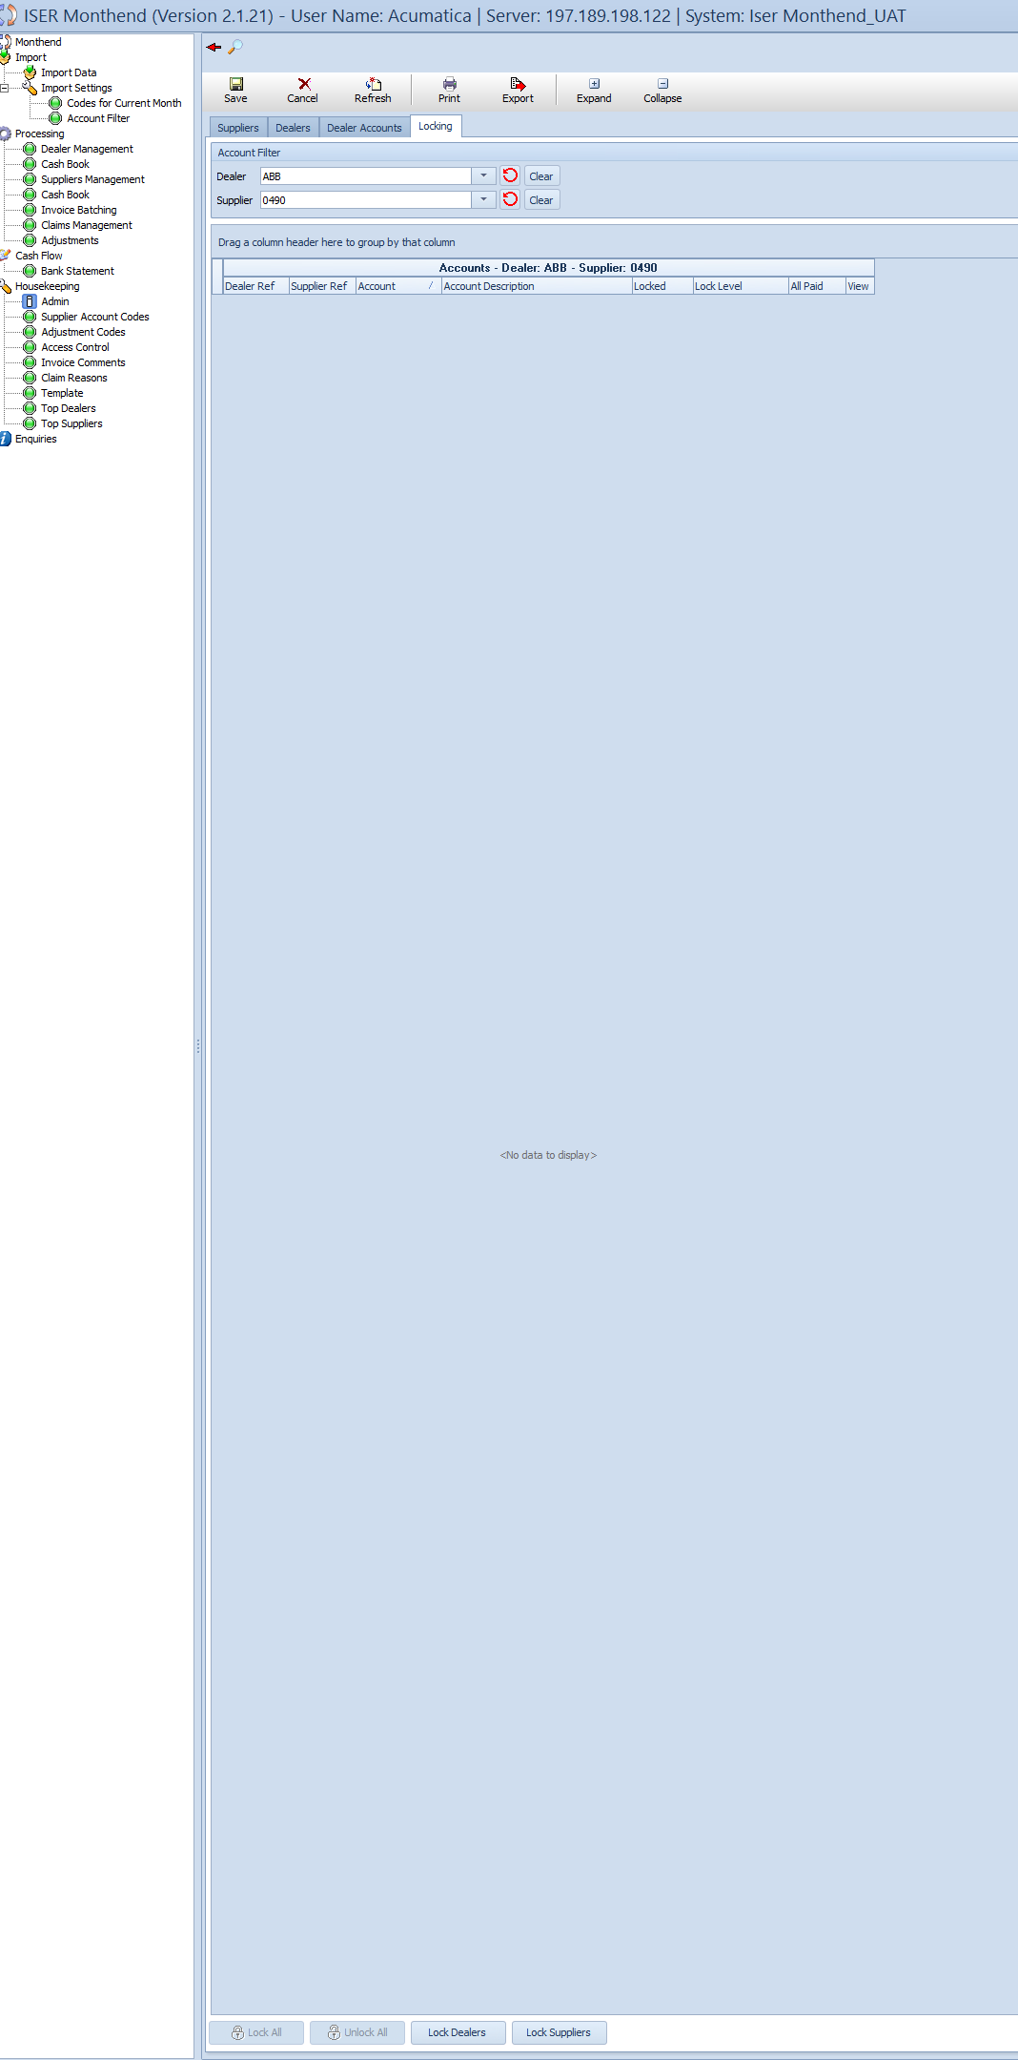**Housekeeping – Admin – Locking**

**Overview**

The “Locking” subview within the “Admin” view of the “Housekeeping” section provides users with tools to manage account locking details efficiently. This view facilitates the locking and unlocking of dealer and supplier accounts, ensuring a secure and controlled system environment.

**Account Filtering**

The “Account Filtering” grid offers functionalities for refining data:

* **Dealer Dropdown:** Select a dealer to filter data.
* **Refresh Button:** Update the dealer dropdown list.
* **Supplier Dropdown:** Select a supplier to filter data.
* **Refresh Button:** Update the supplier dropdown list.
* **Clear Button:** Clear selected filters.

**Main Output Table – Accounts – Dealer: [Dealer Ref] – Supplier [Supplier Ref]**

* **Columns:**

1. Dealers Ref
2. Supplier Ref
3. Account
4. Account Description
5. Locked
6. Lock Level
7. All Paid
8. View

**Locking Operations**

At the bottom of the view, users can find four buttons for efficient locking operations:

* **Lock All:** Locks all accounts displayed in the table.
* **Unlock All:** Unlocks all accounts displayed in the table.
* **Lock Dealers:** Locks accounts specific to dealers.
* **Lock Suppliers:** Locks accounts specific to suppliers.

**Action Buttons**

The standard action buttons – Insert, Edit, Delete, Save, Cancel, Refresh, Print, Export, Expand, and Collapse – are applicable to this subview, providing users with versatile tools for managing account locking details.

**Interaction and Navigation**

Users can efficiently interact with account locking data, utilizing the filtering options, main output table, and locking operations. The tab section at the top ensures seamless navigation between different subviews within the “Admin” view.

### Housekeeping – Supplier Account Codes

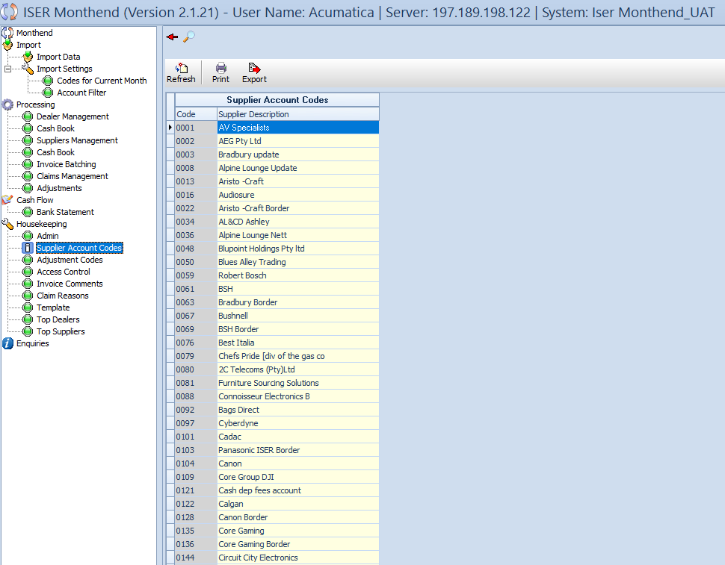

**Overview**

The “Supplier Account Codes” subview within the “Housekeeping” section offers a streamlined interface for managing supplier account codes. Users can efficiently navigate through supplier account details, ensuring accurate and organized information.

**Action Buttons**

At the top of the view, users will find essential action buttons:

* **Refresh:** Update and reload the data in the view.
* **Print:** Generate a printable version of the displayed data.
* **Export:** Export the data for external use or analysis.

**Main Output Table – Supplier Account Codes**

* **Columns:**

1. **Code:** Code associated with the supplier account.
2. **Supplier Description:** Descriptive information about the supplier.

**Interaction and Navigation**

Users can easily interact with supplier account codes, utilizing action buttons for data management. The tab section at the top ensures seamless navigation between different subviews within the “Housekeeping” view.

### Housekeeping – Adjustment Codes

### Housekeeping – Adjustment Codes - Dealer

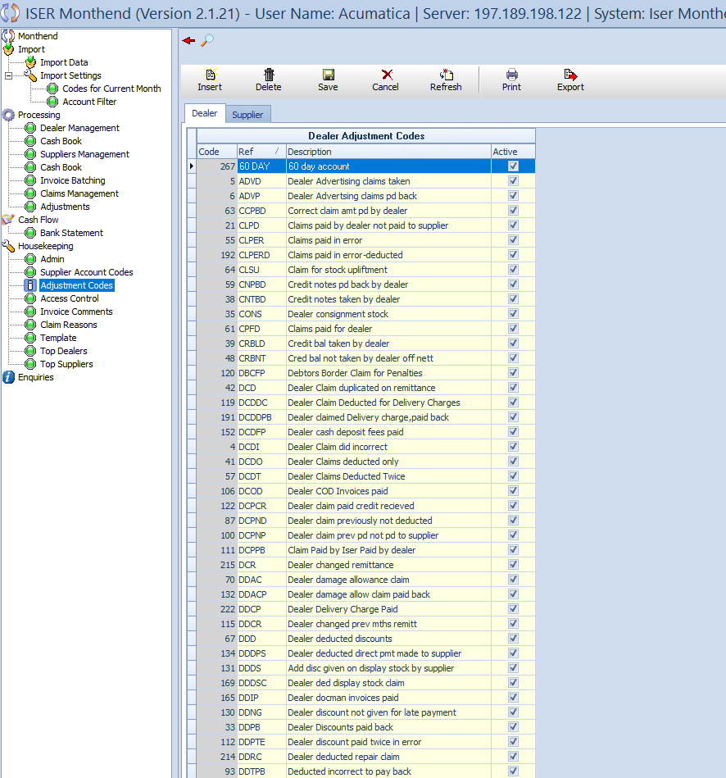

**Overview**

The “Adjustment Codes – Dealer” subview within the “Housekeeping” section provides a centralized location for managing adjustment codes related to dealers. This view enables users to efficiently navigate and maintain adjustment codes details for enhanced system customization.

**Action Buttons**

At the top of the view, users will find essential action buttons:

* **Insert:** Add a new adjustment code record.
* **Delete:** Remove selected adjustment code records.
* **Save:** Save changes made in the view.
* **Cancel:** Discard changes and revert to a pervious state.
* **Refresh:** Update and reload the data in the view.
* **Print:** Generate a printable version of the displayed data.
* **Export:** Export the data for external user or analysis.

**Navigation Tabs**

Users can switch between “Dealers” and “Suppliers” tabs to view adjustment codes specific to each category.

**Main output table – Dealer Adjustment Codes**

* **Columns:**

1. **Code:** Adjustment code associated with the dealer.
2. **Ref:** Reference information for the adjustment code.
3. **Description:** Descriptive details of the adjustment code.
4. **Active:** Checkbox indicating whether the adjustment code is active.

**Interaction and Navigation**

Efficiently manage dealer adjustment codes by utilizing the provided action buttons and navigation tabs. The structured interface ensures ease of use and seamless navigation between different sections.

### Housekeeping – Adjustment Codes – Suppliers

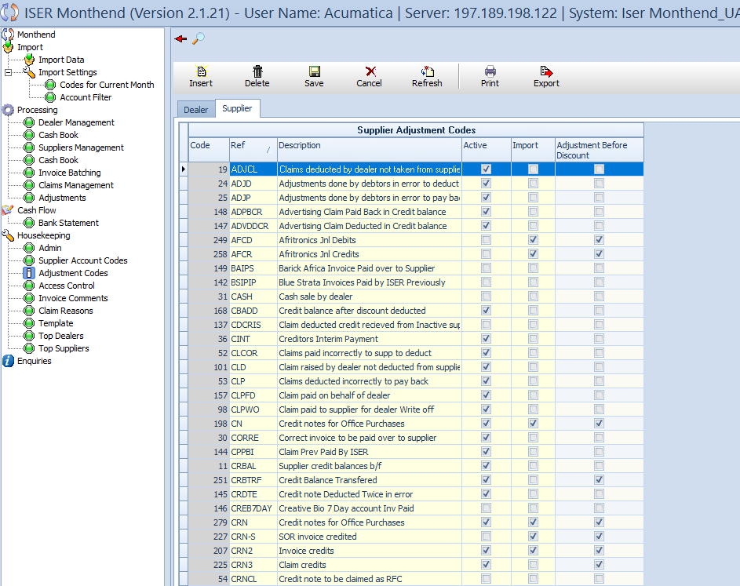

**Overview**

The “Adjustment Codes – Supplier” tabs within the “Housekeeping” section facilitates the management of adjustment codes related to suppliers. Users can efficiently navigate and customize adjustment code details specific to suppliers in this view.

**Action Buttons**

At the top of the view, users will find essential action buttons:

* **Insert:** Add a new adjustment code record.
* **Delete:** Remove selected adjustment code records.
* **Save:** Save changes made in the view.
* **Cancel:** Discard changes and revert to the previous state.
* **Refresh:** Update and reload the data in the view.
* **Print:** Generate a printable version of the displayed data.
* **Export:** Export the data for external use or analysis.

**Main Output Table – Supplier Adjustment Codes**

* **Columns:**

1. **Code:** Adjustment code associated with the supplier.
2. **Ref:** Reference information for the adjustment code.
3. **Description:** Descriptive details of the adjustment code.
4. **Active:** Checkbox indicating whether the adjustment code is active.
5. **Import:** Checkbox for importing adjustment code information.
6. **Adjustment Before Discount:** Checkbox for adjustment before discount.

**Interaction and Navigation**

Efficiently manage supplier adjustment codes by utilizing the provided action buttons. The structured interface ensures ease of use and seamless navigation between different sections.

### Housekeeping – Access Control

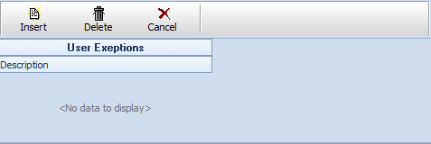

**Overview**

The “Access Control” view within the “Housekeeping” section offers a comprehensive overview of access controls of different users, including viewing rights. Users can efficiently manage access permissions and view details related to user access in this dedicated view.

**Action Buttons**

At the top of the view, users will find essential action buttons:

* **Insert:** Add a new user access control record.
* **Delete:** Remove selected user access control records.
* **Cancel:** Discard changes and revert to the previous state.
* **Refresh:** Update and reload the data in the view.
* **Print:** Generate a printable version of the displayed data.
* **Export:** Export the data for external use or analysis.
* **Save:** Save changes made in the view.

**Main Output Table – User Access Control**

* **Columns:**

1. **Code:** User access control code.
2. **Login:** User login information.
3. **Name:** User’s first name.
4. **Surname:** User’s last name.
5. **Active:** Checkbox indicating whether the user is active.
6. **Reset Password:** Input box to reset user’s password.
7. **Access:** User’s access permissions.
8. **Department:** User’s assigned department.
9. **Email Address:** User’s email address.
10. **Direct Fax Number:** User’s direct fax number.

**User Exceptions**

* Below the main output table, users can find a grid with action buttons:

1. **Insert:** Add a new user exception record.
2. **Delete:** Remove selected user exception records.
3. **Cancel:** Discard changes and revert to the previous state.

* **Output Table – User Exceptions**

1. **Description:** Description of user exceptions.

**Interaction and Navigation**

Efficiently manage user access controls and exceptions by utilizing the provided action buttons. The structured interface ensures ease of use and seamless between different sections.

### Housekeeping – Invoice Comments

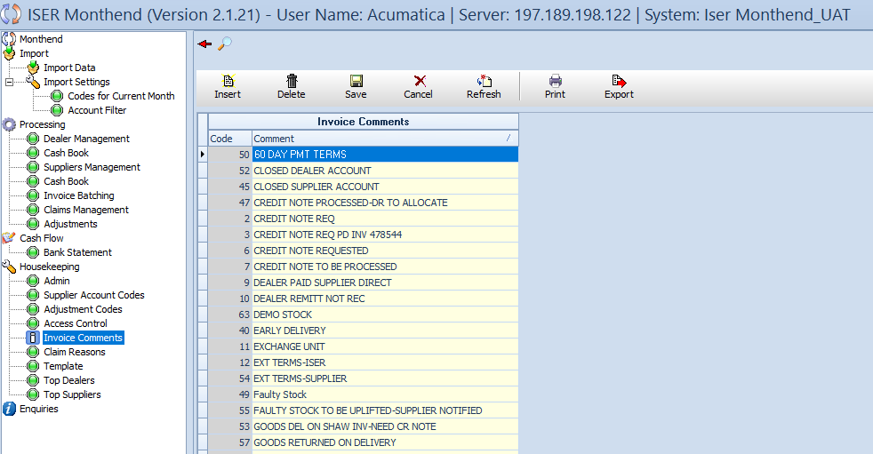

**Overview**

The “Invoice Comments” view within the “Housekeeping” section focuses on managing comments related to dealer management invoices. Users can efficiently handle and track invoice comments through this dedicated view.

**Action Buttons**

At the top of the view, users will find essential action buttons:

* **Insert:** Add a new invoice comment.
* **Edit:** Modify existing invoice comments.
* **Delete:** Remove selected invoice comments.
* **Save:** Save changes made in the view.
* **Cancel:** Discard changes and revert to the previous state.
* **Refresh:** Update and reload the data in the view.
* **Print:** Generate a printable version of the displayed data.
* **Export:** Export the data for external use or analysis.

**Main Output Table – Invoice Comments**

* **Columns:**

1. **Code:** Unique code for each invoice comment.
2. **Comment:** Textual content of the invoice comment.

**Interaction and Navigation**

Efficiently manage invoice comments through the provided action buttons. The inclusion of a “Save” button ensures that changes are securely recorded. Users can seamlessly navigate and interact with the system for optimal usability.

### Housekeeping – Claim Reasons

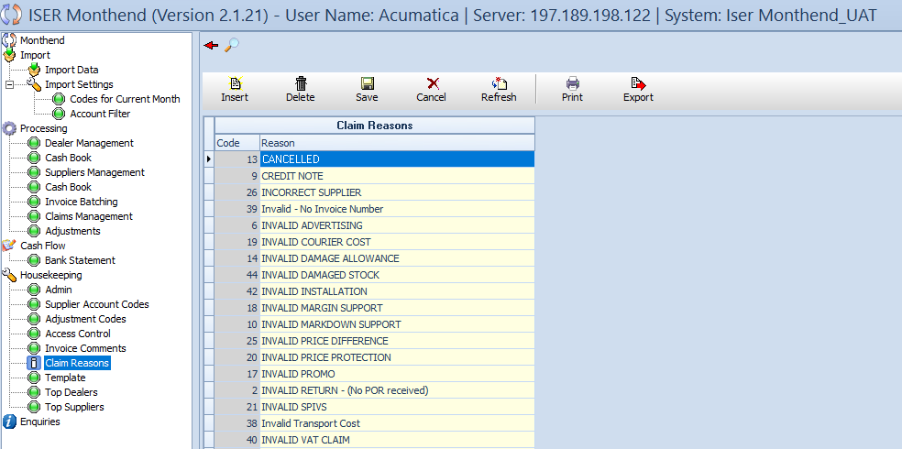

**Overview**

The “Claim Reasons” view within the “Housekeeping” section serves as a central hub for managing claim reasons associated with both suppliers and dealers. Users can efficiently handle and track different claim reasons through this dedicated view.

**Action Buttons**

At the top of the view, users will find essential action buttons:

* **Insert:** Add a new claim reason.
* **Edit:** Modify existing claim reasons.
* **Delete:** Remove selected claim reasons.
* **Save:** Save changes made in the view.
* **Cancel:** Discard changes and revert to the previous state.
* **Refresh:** Update and reload data in the view.
* **Print:** Generate a printable version of the displayed data.
* **Export:** Export the data for external use or analysis.

**Main Output Table – Claim Reasons**

* **Columns:**

1. **Code:** Unique code for each claim reason.
2. **Reason:** Textual description of the claim reason.

**Interaction and Navigation**

Efficiently manage claim reasons through the provided action buttons. The inclusion of a “Save” button ensures that changes are securely recorded. Users can seamlessly navigate and interact with the system for optimal usability.

### Housekeeping – Template

### 

**Overview**

The “Template” view within the “Housekeeping” section empowers users to modify and enhance supplier details and rebate information. Through this view, users can efficiently edit supplier templates, ensuring accurate and up-to-date information for effective business operation.

**Action Buttons**

Located at the top of the view, the following action buttons provide essential functionalities:

* **Save:** Commit changes made in the view.
* **Cancel:** Discard modifications and revert to the previous state.
* **Refresh:** update and reload the data within the view.
* **Print:** Generate a printable version of the displayed data.
* **Export:** Export relevant information for external analysis or documentation.

**Main Output Table – Supplier Template Rebates**

* **Columns:**

1. **Supplier Ref:** Unique reference identifier for each supplier.
2. **Supplier:** Name or designation of the supplier.
3. **Head Office Contact:** Contact person at the supplier’s head office.
4. **Tel:** Telephone number for supplier communication.
5. **Fax:** Fax number for official communication.
6. **Brand Description:** Description of the supplier’s brand.
7. **Rebate:** Supplier rebate information.
8. **Accrual Rebate:** Accrual rebate details.

**Interaction and Navigation**

Users can efficiently navigate and interact with supplier templates using the provided action buttons. The “Save” button ensures that any modifications are securely applied to the system.

### Enquiries

**Overview**

The “Enquiries” Section serves as the comprehensive reporting hub within the month-end application, providing users with valuable insights and analyses across various aspects of the business. Structured into four main tabs – **Dealer, Supplier, Executive, and Cashbook** – the section unfolds an array of sub-tabs, each catering to specific reporting needs. Under the **Dealer** tab, users can explore detailed reports on dealer and account lists, unpaid invoices, adjustment history, accruals, allocations, reconciliations, dealer net and discount, discount schedules, and account discount changes. The **Supplier** tab offers insights into supplier-related data, including lists, unpaid invoices, adjustment history, summaries, remittance advice, claims, and claim summaries. The **Executive** tab provides high-level reports on gross margins, annual growth for suppliers and dealers, consolidated adjustments, and top supplier and dealer gross margins. Finally, the **Cashbook** tab delivers insights into debtors and creditors, with sub-tabs for overs and unders, remittances not submitted, and unprocessed cashbook entries. This structured approach enables users to navigate through a wealth of information, facilitating informed decision-making and strategic planning.

### 4.5.1 Dealer – Dealer List

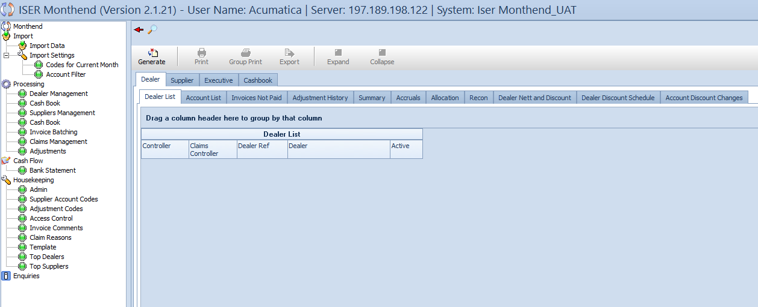

**Overview**

The “Dealer List” sub-tab under the “Dealer” tab in the “Enquiries” section offers a comprehensive overview of dealers, facilitating efficient management and analysis. This sub-tab provides users with essential tools for generating reports, printing, exporting data, and adjusting the view to meet specific needs.

**Action Buttons**

At the top of the view, users can access the following action buttons:

* **Generate:** Initiate the generation of reports based on the data.
* **Print:** Generate a hardcopy or digital version of the dealer list for documentation purposes.
* **Group Print:** Print the Dealers tab as a whole in a grouped format for organized analysis.
* **Export:** Extract relevant dealer information for external analysis or reporting.
* **Expand:** Expand the view for more detailed information.
* **Collapse:** Condense the view for a concise overview.

**Main Output Table – Dealer List**

* **Columns:**

1. **Controller:** Controller assigned to the dealer.
2. **Dealer Ref:** Unique reference identifier for each dealer.
3. **Dealer:** Name or designation of the dealer.
4. **Active:** Indicates whether the dealer is currently active.

**Interaction and Navigation**

Users can efficiently navigate between different tabs and sub-tabs within the “Enquiries” section, enhancing their ability to explore additional data related to dealers. The action buttons provide flexibility in managing and customizing the view.

### Dealer – Account List

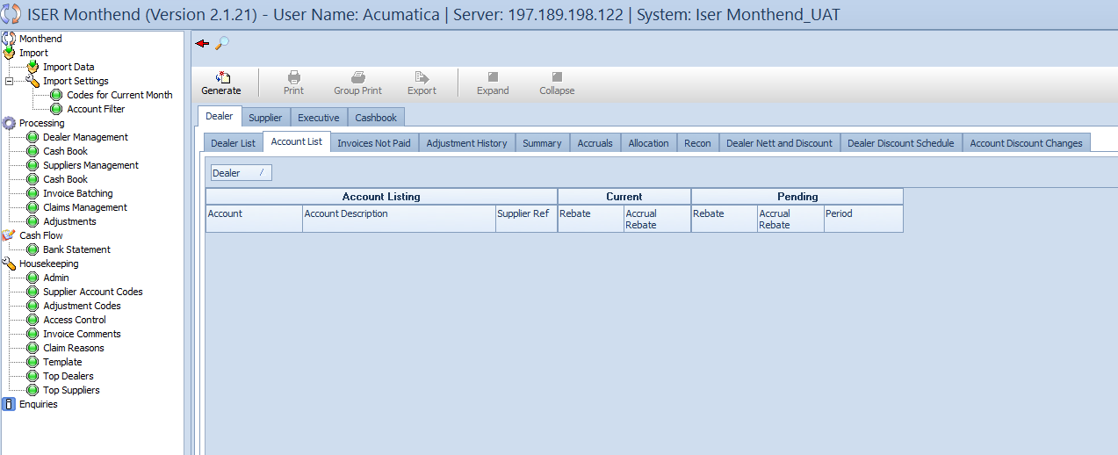

**Overview**

The “Account List” sub-tab under the “Dealer” tab in the “Enquiries” section provides users with a detailed breakdown of dealer accounts, allowing for a comprehensive analysis of current and pending information. The sub-tab is equipped with action buttons that enhance user flexibility and facilitate reporting functionalities.

**Action Buttons**

At the top of the view, users can utilize the following action buttons:

* **Generate:** Initiate the generation of reports based on the displayed account data.
* **Print:** Generate a hardcopy or digital version of the account list for documentation purposes.
* **Group Print:** Print the account list in a grouped format for organized analysis.
* **Export:** Extract relevant information for external analysis or reporting.
* **Expand:** Expand the view for more detailed information.
* **Collapse:** Condense the view for a concise overview.

**Main Output Table – Dealer Account List**

* **Sections:**

1. **Account Listing:** Account, Account Description, and Supplier Reference.
2. **Current:** Rebate and Accrual Rebate.
3. **Pending:** Rebate, Accrual Rebate, and Period.

**Interaction and Navigation**

Users can seamlessly navigate between different sections within the “Dealer Account List” sub-tab, gaining insights into current and pending dealer account details. The action buttons provide ease of use in managing and customizing the view according to specific reporting needs.

### A screenshot of a computerDealer- Invoices Not Paid

**Overview**

The “Invoices Not Paid” sub-tab within the “Dealer” tab of the “Enquiries” section enables users to meticulously analyze outstanding invoices based on diverse parameters. This sub-tab is equipped with an array of action buttons, offering users comprehensive control over an array of action buttons, offering user comprehensive control over generating, printing, and exporting data. The Details grid allows for precise filtering, ensuring focused insights into dealer-related financial data.

**Action Buttons**

Located at the top of the sub-tab, the action buttons include:

* **Generate:** Initiate the generation of detailed reports based on selected parameters.
* **Print:** Generate printable versions of the displayed invoice data for documentation.
* **Group Print:** Print the invoice data in a grouped format for organized analysis.
* **Export:** Extract relevant information for external analysis reporting.
* **Expand:** Expand the view for detailed insights.
* **Collapse:** Condense the view for a concise overview.

**Details Grid**

The details grid facilitates precise filtering of invoice data, providing users with flexibility and control over the displayed information. Users can choose the period, filter by dealer or user, and specify a particular dealer using the dropdown lists and input boxes.

* **Period dropdown:** Choose the specific month for invoice data.
* **By Dealer/ By User/ Select All Radio buttons:** Select the preferred filtering option.
* **Dealer Dropdown:** Choose a specific dealer for focused insights.
* **Refresh Button:** Update the dropdown list based on the latest data.
* **Code Input Box:** Insert the code of the dealer for precise filtering.
* **Use Code Filter Checkbox:** Activate the code filter for specific data representation.

**Main Output Table – Dealer Invoices Not Paid**

The main output table dynamically displays the selected invoice data based on the chosen parameters in the Details grid. Columns include:

* **Import User**
* **Trx Code**
* **Dealer Ref**
* **Dealer**
* **Account Description**
* **Trx Date**
* **Reference**
* **Transaction Description**
* **Amount**
* **Comment**
* **Prev**

**Interaction and Navigation**

Users can efficiently navigate through the “Invoices Not Paid” sub-tab, utilizing the action buttons for diverse functionalities and leveraging the Details grid for precise data filtering. This sub-tab empowers users to gain in-depth insights into outstanding invoices for specific dealers and periods.

### Dealers – Adjustment History

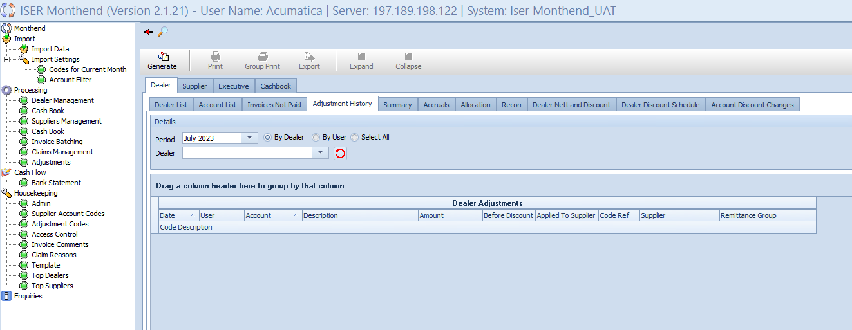

**Overview**

The “Adjustment History” sub-tab under the “Dealer” tab within the “Enquiries” section allows users to track and review historical adjustments made for dealers. This view provides comprehensive insights into adjustments, including details such as dates, users, accounts, amounts, and corresponding supplier and remittance group information.

**Action Buttons**

Located at the top of the view, the following action buttons facilitate various functionalities:

* **Generate:** Execute the generation of adjustment history records.
* **Print:** Generate a printable version of the displayed adjustment history.
* **Group Print:** Print a grouped version of the adjustment history.
* **Export:** Export the adjustment history for external analysis.
* **Expand:** Expand the view to display more details.
* **Collapse:** Collapse the view for a concise overview.

**Details Grid**

The “Details” grid offers a flexibility in customizing the view based on specific parameters:

* **Period Dropdown:** Choose the month for historical adjustments.
* **Selection Radio Button:**

1. **By Dealer:** Filter adjustments based on dealer criteria.
2. **By User:** Filter adjustments based on user criteria.
3. **Select All:** Display adjustments for all dealers.

* **Period Dropdown:** Select a specific dealer for filtered historical data.
* **Refresh Button:** Refresh the dealer dropdown list.

**Main Output Table – Dealer Adjustments**

* **Columns:**

1. **Date:** Date of the adjustment.
2. **User:** User who made the adjustment.
3. **Account:** Account associated with the adjustment.
4. **Description:** Description of the adjustment.
5. **Amount:** The monetary value of the adjustment.
6. **Amount:** The monetary value of the adjustment.
7. **Before Discount:** Amount before any discounts are applied.
8. **Applied to Supplier:** Indicator if the adjustment is applied to the supplier.
9. **Code Ref:** Reference code for the adjustment.
10. **Supplier:** Supplier associated with the adjustment.
11. **Remittance Group:** Remittance group related to the adjustment.
12. **Code Description:** Description corresponding to the reference code.

**Additional Output Table – Supplier Adjustment**

* **Columns:**

1. **Date:** Date of the supplier adjustment.
2. **Supplier:** Supplier involved in the adjustment.
3. **Description:** Description of the adjustment.
4. **Amount:** The monetary value of the adjustment.
5. **Before Discount:** Amount before any discounts are applied.
6. **From Dealer:** Dealer associated with the supplier adjustment.
7. **Remittance Group:** Remittance group related to the adjustment.
8. **Code Ref:** Reference code for the adjustment.
9. **Code Description:** Description corresponding to the reference code.

**Interaction and Navigation**

Users can interact with the view using the provided action buttons, customize parameters in the “Details” grid, and explore historical adjustments made for both dealers and suppliers.

### Dealer – Summary

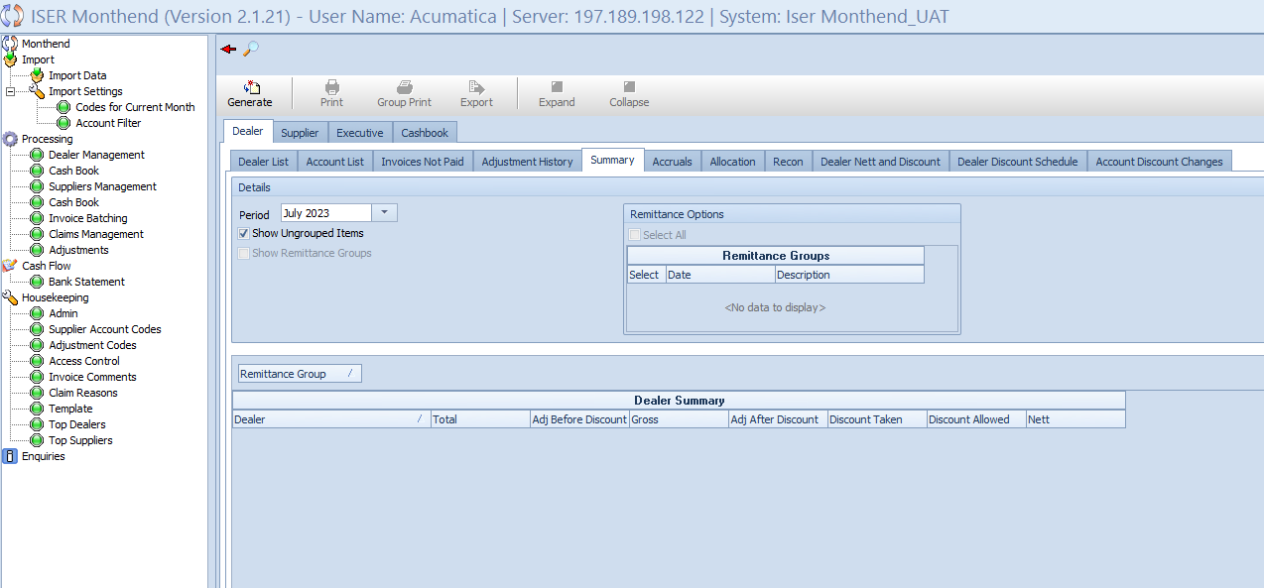

**Overview**

The “Summary” sub-tab under the “Dealer” tab in the “Enquiries” section provides a comprehensive summary of dealer-related information, offering insights into various financial aspects. Users can analyze key metrics such as total adjustments, gross amounts, discounts, and net values, facilitating a quick overview of the financial status.

**Action Buttons**

At the top of the view, the following action buttons offer essential functionalities:

* **Generate:** Execute the generation of summary reports.
* **Print:** Generate a printable version of the displayed summary.
* **Group Print:** Print a grouped version of the summary.
* **Export:** Export summary data for external analysis.
* **Expand:** Expand the view to display more details.
* **Collapse:** Collapse the view for a concise overview.

**Details Grid**

The “Details” grid enables users to customize the view based on specific parameters:

* **Period Dropdown:** Choose the month for the summary.
* **Show Ungrouped Items Checkbox:** Include ungrouped items in the summary.
* **Show Remittance Group Checkbox:** Display remittance group information.

**Remittance Options Grid**

The “Remittance Options” grid allows users to select specific remittance groups for inclusion in the summary:

* **Select All Checkbox:** Select all available remittance groups.

**Remittance Groups Output Table**

* **Columns:**

1. **Select:** Checkbox for selecting individual remittance groups.
2. **Date:** Date of the remittance group.
3. **Description:** Description of the remittance group.

**Main Output Table – Dealer Summary**

* **Columns:**

1. **Dealer:** Dealer name or identifier.
2. **Total:** Total financial amount for the dealer.
3. **Adj Before Discount:** Adjustments before any discounts.
4. **Gross:** Gross financial value.
5. **Adj After Discount:** Adjustments after applying discounts.
6. **Discount Taken:** Total discount amount taken.
7. **Discount Allowed:** Total discount amount allowed.
8. **Nett:** Net Financial value after adjustments and discounts.

**Interaction and Navigation**

Users can interact with the view using the provided action buttons, customize parameters in the “Details” grid, and review the comprehensive summary of financial metrics for dealers.

### Dealer- Accruals

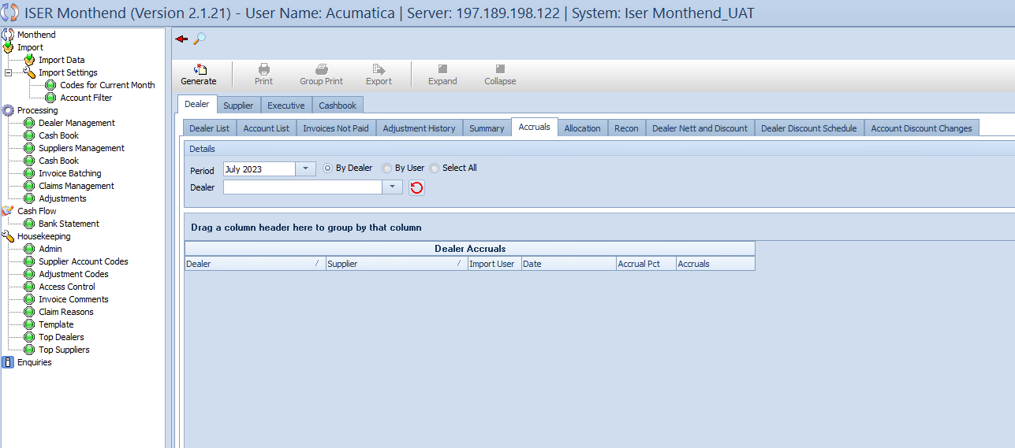

**Overview**

The “Accruals” sub-tab within the “Dealer” tab of the “Enquiries” section provides a detailed overview of dealer and supplier accruals. Users can analyze accrual percentages, dates, and related information, offering insights into financial accruals for effective management.

**Action Buttons**

At the top of the view, users can find the following action buttons for streamlined functionality:

* **Generate:** Initiate the generation of accrual records.
* **Print:** Generate a printable version of the displayed accruals.
* **Group Print:** Print a grouped version of the accruals.
* **Export:** Export accrual data for external analysis.
* **Expand:** Expand the view for more detailed information.
* **Collapse:** Collapse the view to maintain a concise overview.

**Details Grid**

The “Details” grid allows users to customize the view based on specific parameters:

* **Period Dropdown:** Choose the month for accrual records.
* **Radio Buttons:** Select options like By Dealer, By User, or Select All.
* **Dealer Dropdown:** Select a specific dealer for filtered accrual data.
* **Refresh Button:** Refresh the dropdown lists for updated data.

**Main Output Table – Dealer Accruals**

* **Columns:**

1. **Dealer:** Dealer name or identifier.
2. **Supplier:** Supplier information associated with the accrual.
3. **Import User:** User responsible for importing the accrual data.
4. **Date:** Date of the accrual record.
5. **Accrual Pct:** Accrual percentage for the specified dealer and supplier.
6. **Accrual:** Accrual amounts for effective financial tracking.

**Interaction and Navigation**

Users can interact with the view using the provided action buttons, customize parameters in the “Details” grid, and review comprehensive accrual information for dealers and suppliers.

### Dealer – Allocation

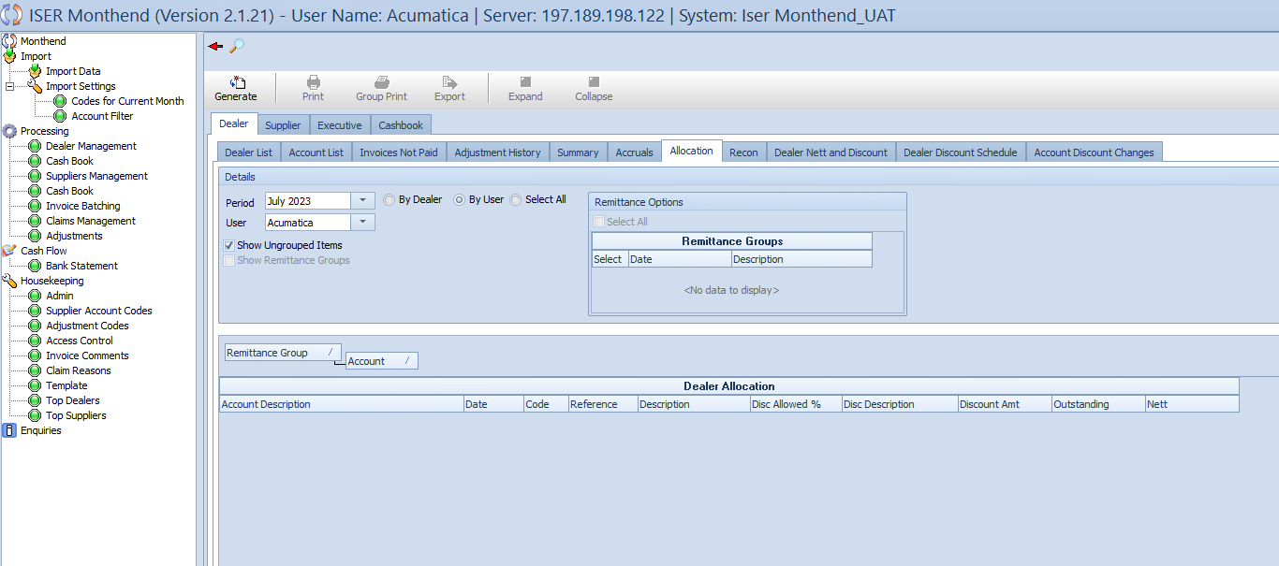

**Overview**

The “Allocation” sub-tab within the “Dealer” tab of the “Enquiries” section facilitates efficient allocation tracking for dealers. This view empowers users to allocate transactions to specific accounts, offering insights into discount details, outstanding amounts, and net figures for enhanced financial management.

**Action Buttons**

The top section of the view provides the following essential action buttons:

* **Generate:** Initiate the generation of allocation records.
* **Print:** Generate a printable version of the displayed allocation details.
* **Group Print:** Print a grouped version of the allocation details.
* **Export:** Export allocation data for external analysis.
* **Expand:** Expand the view for more detailed information.
* **Collapse:** Collapse the view for a concise overview.

**Details Grid**

The “Details” grid allows users to customize the allocation view based on specific parameters:

* **Period Dropdown:** Choose the month for allocation records.
* **Radio Buttons:** Select options like By Dealer, By User, or Select All.
* **User Dropdown:** Select a specific user filtered allocation data.
* **Show Ungrouped Items Checkbox:** Toggle to display ungrouped allocation items.
* **Show Remittance Group Checkbox:** Toggle to show remittance group details.

**Remittance Options Grid**

Inside the “Details” grid, the “Remittance Options” grid offers users the ability to manage remittance groups effectively. It comprises a “Select All” checkbox and an output table with columns: **Select, Date, and Description.**

**Main Output Table – Dealer Allocation**

* **Columns:**

1. **Account Description:** Description of the allocated account.
2. **Date:** Date associated with the allocation.
3. **Code:** Code associated with the allocation.
4. **Reference:** Reference information for the allocation.
5. **Description:** Detailed description for the allocation.
6. **Disc Allowed %:** Discount allowed percentage for the allocation.
7. **Disc Description:** Description of the discount for the allocation.
8. **Discount Amount:** Amount of discount allocated.
9. **Outstanding:** Outstanding amount for the allocation.
10. **Nett:** Net amount for the allocation.

**Interaction and Navigation**

Users can seamlessly interact with the view using the provided action buttons, customize parameters in the “Details” grid, and explore detailed allocation information for effective financial tracking.

### Dealer – Recon

### 

**Overview**

The “Recon” sub-tab within the “Dealer” tab which is part of the “Enquiries” section provides users with a comprehensive view of reconciliation. This view allows users to reconcile dealer transactions, providing insights into various financial aspects such as amount, gross, figures, discounts, accruals, and net amounts.

**Action Buttons**

At the top of the view, users can utilize the following actions buttons:

* **Generate:** Initiate the generation of reconciliation records.
* **Print:** Generate a printable version of the displayed reconciliation details.
* **Group Print:** Print a grouped version of the reconciliation details.
* **Export:** Export reconciliation data for external analysis.
* **Expand:** Expand the view for more detailed information.
* **Collapse:** Collapse the view for a concise overview.

**Details Grid**

The “Details” grid provides customization options for the reconciliation view:

* **Period Dropdown:** Choose the month for reconciliation records.
* **Radio Buttons:** Select options like By Dealer, By User, or Select All.
* **Dealer Dropdown:** Select a specific dealer for filtered reconciliation data.
* **Refresh Button:** Refresh the dealer dropdown list.
* **Show Ungrouped Items Checkbox:** Toggle to display ungrouped reconciliation items.
* **Show Remittance Group Checkbox:** Toggle to show remittance group details.

**Remittance Options Grid**

Within the “Details” grid, the “Remittance Options” grid allows users to manage remittance groups effectively. It comprises a “Select All” checkbox and an output table with columns: Select, Date, and Description.

**Main Output Table – Dealer Recon**

* **Columns:**

1. **Dealer:** Name or identifier of the reconciled dealer.
2. **Amount:** Total amount for reconciliation.
3. **Gross:** Gross figures related to the reconciliation.
4. **Adj Before Discount:** Adjustments made before applying discounts.
5. **Nett:** Net amount for the reconciliation.
6. **% Taken:** Percentage of discount taken.
7. **Discount Taken:** Amount of discount taken.
8. **% Allowed:** Percentage of discount allowed.
9. **Discount Allowed:** Amount of discount allowed.
10. **Accruals:** Accruals associated with the reconciliation.

**Interaction and Navigation**

Users can efficiently interact with the view using the provided action buttons, customize parameters in the “Details” grid, and delve into detailed reconciliation information for effective financial management.

### Dealer – Dealer Net and Discount

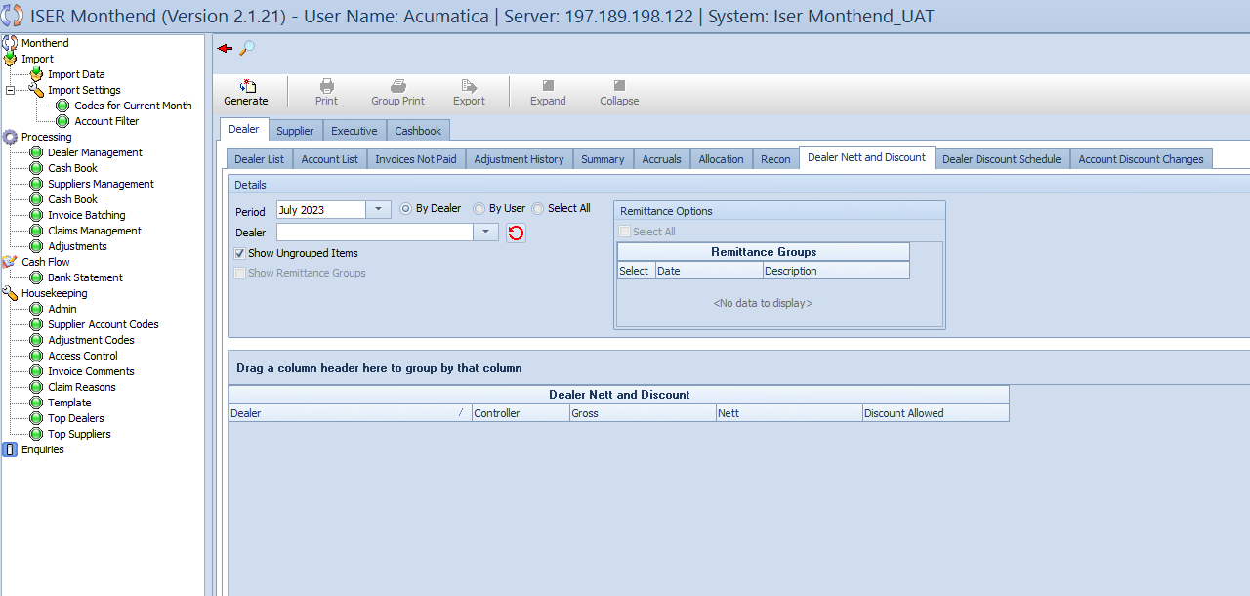

**Overview**

The “Dealer Net and Discount” sub-tab within the “Dealer” tab of the “Enquiries” section provides users with a consolidated view of net figures and allowed discounts for specific dealers. This view enables users to analyze and comprehend key financial aspects, including gross figures, net amounts, and permitted discounts.

**Action Buttons**

Located at the top of the view, users can utilize the following action buttons:

* **Generate:** Initiate the generation of net and discount records.
* **Print:** Generate a printable version of the displayed net and discount details.
* **Group Print:** Print a grouped version of the net and discount details.
* **Export:** Export net and discount data for external analysis.
* **Expand:** Expand the view for more detailed information.
* **Collapse:** Collapse the view for a more concise overview.

**Details Grid**

The “Details” grid offers customization options for the net and discount view:

* **Period Dropdown:** Choose the month for net and discount records.
* **Radio Buttons:** Select options like By Dealer, By User, or Select All.
* **Dealer Dropdown:** Select a specific dealer for filtered net and discount data.
* **Refresh Button:** Refresh the dealer dropdown list.
* **Show Ungrouped Items Checkbox:** Toggle to display ungrouped net and discount items.
* **Show Remittance Group Checkbox:** Toggle to show remittance group details.

**Remittance Options Grid**

Within the “Details grid, the “Remittance Options” grid allows users to manage remittance groups effectively. It comprises a “Select All” checkbox and an output table with columns: Select, Date, and Description.

**Main Output Table – Dealer Net and Discount**

* **Columns:**

1. **Dealer:** Name or identifier of the relevant dealer.
2. **Controller:** Controller associated with the dealer.
3. **Gross:** Gross figures related to the net and discount view.
4. **Nett:** Net amount for the specific dealer.
5. **Discount Allowed:** Amount of discount allowed for the dealer.

**Interaction and Navigation**

Users can efficiently navigate through the view using provided action buttons, customize parameters in the “Details” grid, and gain valuable insights into net figures and permitted discounts for effective financial management.

### 4.4.10 Dealer – Dealer Discount Schedule

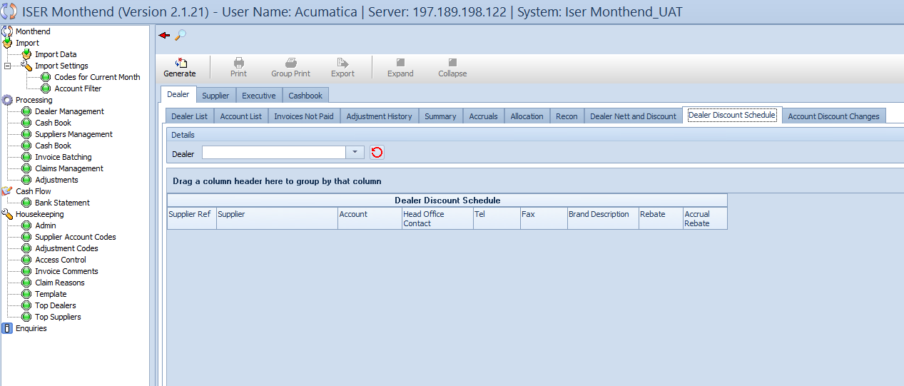

**Overview**

The “Dealer Discount Schedule” sub-tab within the “Dealer” tab of the “Enquiries” section empowers users to access and manage the discount schedules for specific dealers. This view provides a comprehensive overview of scheduled rebates and accruals for improved financial analysis and decision making.

**Action Buttons**

Located at the top of the view, users can utilize the following action buttons:

* **Generate:** Initiate the generation of the dealer discount schedule.
* **Print:** Generate a printable version of the displayed discount schedule.
* **Group Print:** Print a grouped version of the discount schedule.
* **Export:** Export discount schedule data for external analysis.
* **Expand:** Expand the view for more detailed information.
* **Collapse:** Collapse the view for a concise overview.

**Details Grid**

The “Details” grid offers customization options for the discount schedule:

* **Dealer Dropdown:** Select a specific dealer to view their discount schedule.
* **Refresh button:** Refresh the dealer dropdown list.

**Main Output Table – Dealer Discount Schedule**

* **Columns:**

1. **Supplier Ref:** Unique reference identifier for each supplier.
2. **Supplier:** Name or designation of the supplier.
3. **Account:** Dealer’s account details.
4. **Head Office Contact:** Contact person at the dealer’s head office.
5. **Tel:** Telephone number for dealer communication.
6. **Fax:** Fax number for official communication.
7. **Brand Description:** Description of the dealer’s brand.
8. **Rebate:** Scheduled rebate information for the dealer.
9. **Accrual Rebate:** Scheduled accrual rebate details.

**Interaction and Navigation**

Users can efficiently navigate through the discount schedule view using the provided action buttons and customize parameters in the “Details” grid. The “Expand” and “Collapse” buttons offer flexibility for viewing detailed information for a concise overview.

### 4.4.11 Dealer – Dealer Discount Changes

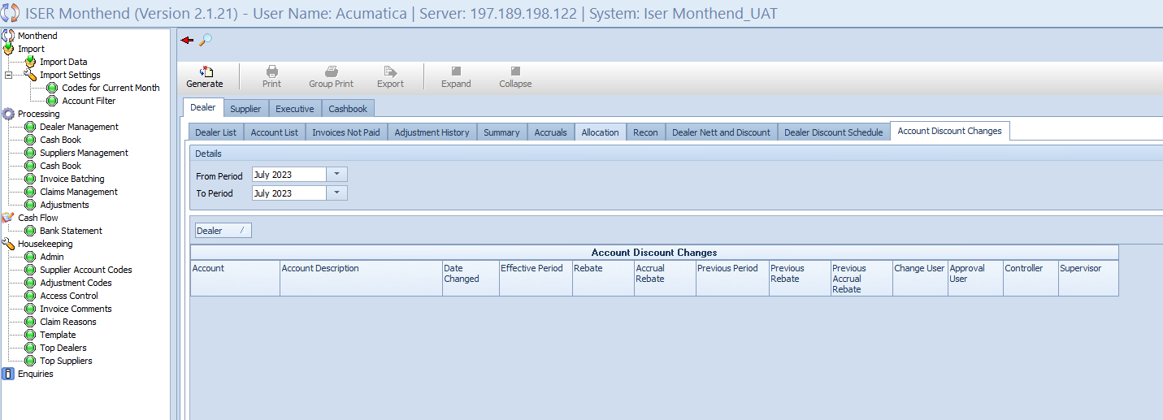

**Overview**

The “Account Discount Changes" sub-tab within the “Dealer” tab of the “Enquiries” section provides users with insights into modification made to dealer account discounts. This view allows for the efficient tracking of changes over time, enabling users to assess the impact on financial structures and make informed decisions.

**Action Buttons**

At the top of the view, users can access the following action buttons:

* **Generate:** Initiate the generation of account discount changes.
* **Print:** Generate a printable version of the displayed changes.
* **Group Print:** Print a grouped version of the discount changes.
* **Export:** Export discount change data for external analysis.
* **Expand:** Expand the view for more detailed information.
* **Collapse:** Collapse the view for a concise overview.

**Details Grid**

The “Details” grid facilitates customization of the discount changes:

* **From Period Dropdown:** Select the starting period for tracking changes.
* **To Period Dropdown:** Select the ending period for tracking changes.

**Main Output Table – Account Discount Changes**

* **Columns:**

1. **Account:** Dealer’s account details.
2. **Account Description:** Description of the dealer’s account.
3. **Date Changed:** Date when the discount changes were made.
4. **Effective Period:** Period during which the changes are effective.
5. **Rebate:** Updated rebate information.
6. **Accrual Rebate:** Updated accrual rebate details.
7. **Previous Period:** Previous period’s information.
8. **Previous Rebate:** Previous rebate details.
9. **Previous Accrual Rebate:** Previous accrual rebate details.
10. **Change User:** User responsible for the changes.
11. **Approval User:** User who approved the changes.
12. **Controller:** Controller overseeing the changes.
13. **Supervisor:** Supervisor providing oversight.

**Interaction and Navigation**

Users can efficiently navigate the account discount changes view using the provided action buttons and customize parameters in the “Details” grid. The “Expand”  
 and “Collapse” buttons offer flexibility for viewing detailed information or a concise overview.

### 4.6.1 Supplier – Supplier List

**Overview**

The “Supplier List” sub-tab within the “Supplier” tab of the “Enquiries” section serves as a comprehensive source of information about suppliers. This view enables users to access details such as supplier references, names, controllers, discount descriptions, discount percentages, and their activation status. Users can efficiently navigate and analyze supplier-related data to make informed decisions.

**Action Buttons**

Located at the top of the view, the following actions buttons provide essential functionalities:

* **Generate:** Initiate the generation of supplier information.
* **Print:** Generate a printable version of the displayed supplier list.
* **Group Print:** Print a grouped version of the supplier list.
* **Export:** Export supplier data for external analysis.
* **Expand:** Expand the view for more detailed information.
* **Collapse:** Collapse the view for a concise overview.

**Main Output Table – Supplier List**

Columns:

* **Supplier Ref:** Unique reference identifier for each supplier.
* **Supplier:** Name or designation of the supplier.
* **Controller:** Individual overseeing the supplier.
* **Discount Description:** Description of the supplier’s discount.
* **Discount:** Supplier’s discount percentage.
* **Active:** Checkbox indicating the activation status of the supplier.

**Interaction and Navigation**

Users can efficiently navigate and interact with the supplier list using the provided action buttons. The “Expand” and “Collapse” buttons offer flexibility for viewing detailed supplier information or a concise overview.

*Note: The “Supplier” tab provides a centralized location to explore and analyze details about suppliers.*

### A screenshot of a computer4.6.2 Supplier – Invoices Not Paid

**Overview**

The “Invoices not Paid” sub-tab within the “Suppliers” tab of the “Enquiries” section offers a detailed overview of unpaid invoices associated with suppliers. Users can utilize this view to track and manage outstanding payments, gaining insights into specific transactions, amounts, and associated details. The sub-tab ensures efficient navigation and analysis of unpaid invoices for enhanced financial oversight.

**Action Buttons**

Located at the top of the view, the following action buttons provide essential functionalities:

* **Generate:** Initiate the generation of data related to unpaid invoices.
* **Print:** Generate a printable version of the displayed information.
* **Group Print:** Print a grouped version of the unpaid invoices.
* **Export:** Export data for external analysis.
* **Expand:** Expand the view for more detailed information.
* **Collapse:** Collapse the view for a concise overview.

**Details Grid**

* **Period Dropdown:** Select the desired month and year for filtering unpaid invoices.
* **Radio Group:** Choose from the options: By Supplier, By User, Select All.
* **Supplier Dropdown:** Select a specific supplier for filtered data on the main output table.
* **Refresh Button:** Update the supplier dropdown list.
* **Show Remittance Groups Checkbox:** Toggle to display remittance groups.

**Remittance Options Grid**

* **Select All Checkbox:** Select all remittance groups.
* **Remittance Groups Table:** Columns – Select, Date, Description.

**Main Output Table** – **Supplier Invoices Not Paid – Supplier: [Supplier code chosen in dropdown list] – Period: [Period chosen in dropdown list].**

* **Columns:**

1. Import User
2. Supplier Ref
3. Debtors Clark
4. Supplier
5. Dealer Ref
6. Dealer
7. Account Description
8. TRX Date
9. Reference
10. Transaction Description
11. Amount
12. Comment
13. Prev

**Interaction and Navigation**

Users can efficiently navigate and interact with the tab using the provided action buttons. The “Expand” and Collapse” buttons offer flexibility for viewing detailed invoice information or a concise overview.

*Note: The “Invoices Not Paid” sub-tab provides a centralized location to monitor and manage outstanding payments, facilitating improved financial control and decision-making processes.*

### 4.6.3 Supplier – Adjustment History

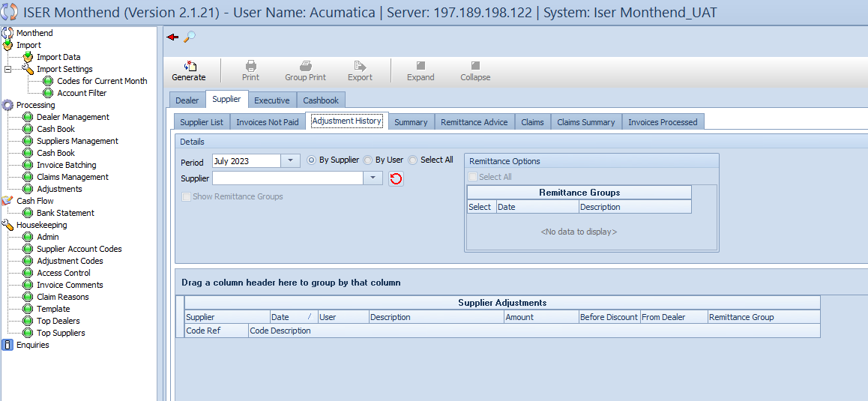

**Overview:**

The “Adjustment History” sub-tab within the “Supplier” tab of the “Enquiries” section provides a comprehensive overview of historical adjustments related to suppliers. Users can utilize this view to track and analyze adjustments made over specific periods, gaining insights into adjustment details, amounts and associated codes. The sub-tab ensures efficient navigation and analysis of adjustment history for enhanced financial oversight.

**Action Buttons**

Located at the top of the view, the following action buttons provide essential functionalities:

* **Generate:** Initiate the generation of data related to adjustment history.
* **Print:** Generate a printable version of the displayed information.
* **Export:** Export data for external analysis.
* **Expand:** Expand the view for more detailed information.
* **Collapse:** Collapse the view for a concise overview.

**Details Grid**

* **Period Dropdown:** Select the desired month and year for filtering adjustment history.
* **Radio Group:** Choose from options: By Supplier, By User, Select All.
* **Supplier Dropdown:** Select a specific supplier for filtered data.
* **Refresh Button:** Update the supplier dropdown list.
* **Show Remittance Groups Checkbox:** Toggle to display remittance groups.

**Remittance Options Grid**

* **Select All Checkbox:** Select all remittance groups.
* **Remittance Groups Table:** Columns – Select, Date, Description.

**Main Output Table – Supplier Adjustments**

* **Columns:**

1. Supplier
2. Date
3. User
4. Description
5. Amount
6. Before Discount
7. From Dealer
8. Remittance Group
9. Code Ref
10. Code Description

**Secondary Output Table – Dealer Adjustment**

* Columns:

1. Date
2. Account
3. Description
4. Amount
5. Before Discount
6. Apply To Supplier
7. Remittance Group
8. Code Ref
9. Code Description

**Interaction and Navigation**

Users can efficiently navigate and interact with adjustment history data using the provided action buttons. The “Expand” and “Collapse” buttons offer flexibility for viewing detailed adjustment information or a concise overview.

*Note: The “Adjustment History” sub-tab serves as a centralized location to review historical adjustments related to supplier, facilitating comprehensive financial analysis and decision-making processes.*

### 4.6.4 Supplier – Summary

**Overview**

The “Summary” sub-tab under the “Supplier” tab in the “Enquiries” section provides a consolidated view of essential financial metrics related to suppliers. Users can access critical information, including total amounts, adjustments before and after discounts, gross figures, discounts, annual rebates, and net amounts. The sub-tab facilitates a comprehensive understanding of supplier financial performance, enabling efficient decision-making.

**Action Buttons**

Located at the top of the view, the following action buttons offer essential functionalities:

* **Generate:** Trigger the generation of summary data for supplier finances.
* **Print:** Generate a printable version of the displayed information.
* **Export:** Export data for external analysis.
* **Expand:** Expand the view to reveal detailed information.
* **Collapse:** Collapse the view for a concise overview.

**Details Grid**

* **Period Dropdown:** Select the desired month and year for filtering summary data.
* **Show Ungrouped Items Checkbox:** Toggle to display ungrouped items in the summary.
* **Show Remittance Groups Checkbox:** Toggle to display remittance groups in the summary.
* **Refresh Button:** Update the view with the latest data.

**Main Output Table – Supplier Summary**

* **Columns:**

1. Supplier Ref
2. Supplier
3. Total
4. Adj Before Discount
5. Gross
6. Discount
7. Annual Rebate
8. Adj After Discount
9. Nett

**Interaction and Navigation**

Users can efficiently navigate and interact with supplier summary data using the provided action buttons. The “Expand” and “Collapse” buttons allow flexibility in viewing detailed information or obtaining a concise overview. The “Show Ungrouped Items” and “Show Remittance Groups” checkboxes provide additional control over the displayed content in the summary.

*Note: The “Summary” sub-tab offers a centralized location for assessing crucial financial metrics related to suppliers, contributing to informed decision-making and strategic financial analysis.*

### 4.6.5 Supplier – Remittance Advice

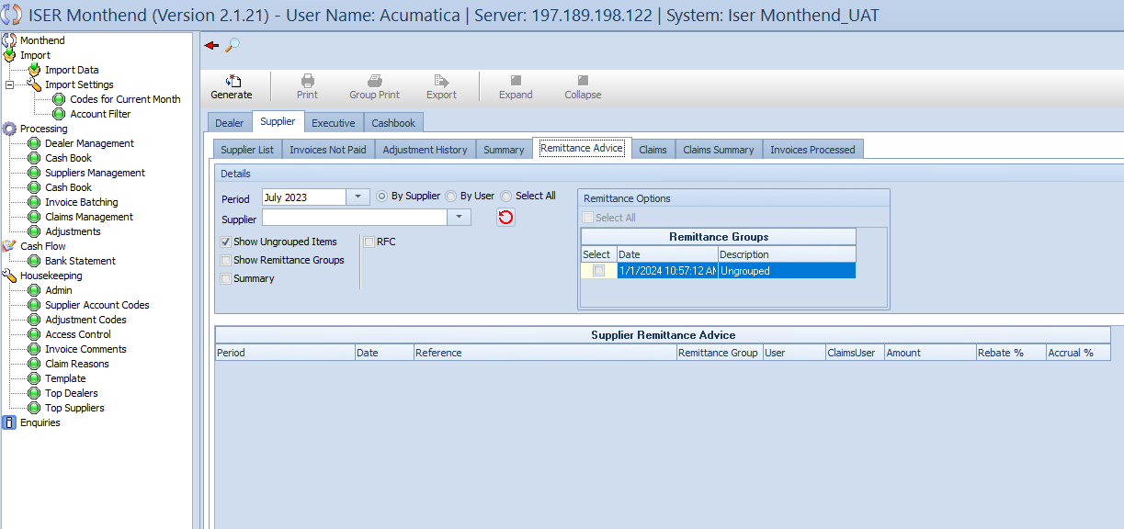



**Overview**

The “Remittance Advice” sub-tab under the “Supplier” tab in the “Enquiries” section allows users to access detailed information related to supplier remittances. This sub-tab presents a comprehensive view, including critical details such as period, date, reference, remittance group, user information, claims user, amounts, rebate percentages, and accrual percentages. Users can navigate and analyze supplier remittance advice efficiently through this dedicated sub-tab.

**Action Buttons**

Located at the top of the view, the following action buttons provide essential functionalities:

* **Generate:** Trigger the generation of remittance advice data for suppliers.
* **Print:** Generate a printable version of the displayed remittance advice.
* **Export:** Export remittance advice data for external analysis.
* **Expand:** Expand the view to reveal detailed information.
* **Collapse:** Collapse the view for a concise overview.

**Details Grid**

* **Period Dropdown:** Select the desired month and year for filtering remittance advice data.
* **Radio Group (By Supplier, By User, Select All):** Choose the relevant option for viewing remittance advice.
* **Supplier Dropdown:** Select a specific supplier for filtered remittance advice data.
* **Refresh Button:** Update the view with the latest data.
* **Summary Checkbox:** Toggle to display a summary in the remittance advice.
* **RFC Checkbox:** Toggle to include RFC (Request for Credit) information in the remittance advice.

**Main Output Table – Supplier Remittance Advice**

* **Columns:**

1. Period
2. Date
3. Reference
4. Remittance Group
5. User
6. Claims User
7. Amount
8. Rebate %
9. Accrual %

**Small Output Grid – Remittance Advice Total**

This grid provides a summary of the remittance advice, including total amounts and percentages.

**Interaction and Navigation**

Users can efficiently navigate and interact with supplier remittance advice using the provided action buttons. The “Expand” and “Collapse” buttons allow flexibility in viewing detailed information or obtaining a concise overview. The “Summary” and “RFC” checkboxes provide additional control over the displayed content in the remittance advice.

*Note: The “Remittance Advice” sub-tab offers a centralized platform for reviewing and analyzing detailed supplier remittance information, facilitating effective financial management and decision-making.*

### A screenshot of a computer4.6.5 Claims – Supplier



**Overview:**

The “Claims” sub-tab under the “Supplier” tab in the “Enquiries” section provides users with a detailed overview of supplier claims information. This sub-tab empowers users to review and manage claims information. This sub-tab empowers users to review and manage claims efficiently, featuring crucial details such as supplier information, claims controller, amounts before discount, description, period, date, reference, remittance group, user information, rebate percentages, accrual percentages, invoice numbers, credit note numbers, credit note numbers, authorization status, reasons, and validity.

**Action Buttons**

Located at the top of the view, the following action buttons provide essential functionalities:

* **Generate:** Trigger the generation of claims data for suppliers.
* **Print:** Generate a printable version of the displayed claims.
* **Export:** Export claims data for external analysis.
* **Expand:** Expand the view to reveal detailed information.
* **Collapse:** Collapse the view for a concise overview.

**Details Grid**

* **From Period Dropdown:** Select the starting period for filtering claims data.
* **To Period Dropdown:** Select the ending period for filtering claims data.
* **Radio Group (By Supplier, By User, Select All):** Choose the relevant option for viewing claims.
* **Supplier Dropdown:** Select a specific supplier for filtered claims data.
* **Refresh Button:** Update the view with the latest data.
* **Summary Checkbox:** Toggle to display a summary in the claims information.
* **RFC Checkbox:** Toggle to include RFC (Request for Credit) information in the claims.

**Main Output Table: Supplier Claims**

* **Columns:**

1. Supplier
2. Claims Controller
3. Before Discount
4. Description
5. Period
6. Date
7. Reference
8. Remittance Group
9. User
10. Amount
11. Rebate %
12. Accrual %
13. Invoice Number
14. Credit Note Number
15. Authorization
16. Reason
17. Apply To Supplier
18. Valid

**Small Output Grid – Claims Total**

This grid provides a summary of the claims, including total amounts and percentages.

**Interaction and Navigation**

Users can efficiently navigate and interact with supplier claims using the provided action buttons. The “Expand” and “Collapse” buttons allow flexibility in viewing detailed information or obtaining a concise overview. The “Summary” and “RFC” checkboxes provide additional control over the displayed content in the claims.

*Note: The “Claims” sub-tab offers a centralized platform for reviewing, analyzing, and managing supplier claims, facilitating effective financial management and decision making.*

### A screenshot of a computer4.6.6 Supplier – Claims Summary

**Overview**

The “Claims Summary” sub-tab under the “Supplier” tab in the “Enquiries” section provides users with a comprehensive summary of supplier claims during a specified period. Users can leverage this view to gain insights into the frequency of claims, the total count, and the aggregated claim amounts. The sub-tab features a Details grid for selecting the period, enabling users to focus on specific claim data.

**Action Buttons**

Located at the top of the view, the following action buttons provide essential functionalities:

* **Generate:** Trigger the generation of claims summary data for suppliers.
* **Print:** Generate a printable version of the displayed claims summary.
* **Export:** Export claims summary data for external analysis.
* **Expand:** Expand the view to reveal detailed information.
* **Collapse:** Collapse the view for a concise overview.

**Details Grid**

* **From Period Dropdown:** Select the starting period for the claims summary.
* **To Period Dropdown:** Select the ending period for the claims summary.
* **Refresh Button:** Update the view with the latest data.

**Main Output Table – Claims Summary**

* **Columns:**

1. **Supplier Descr:** Description of the supplier.
2. **ClaimCnt:** Total count of claims for the specified period.
3. **ClaimAmt:** Aggregated number of claims for the specified period.

**Interaction and Navigation**

Users can efficiently interact with and navigate the “Claims Summary” sub-tab. Utilize the “Generate” button to obtain summary data based on the selected period. The “Expand” and “Collapse” buttons provide flexibility in viewing detailed information or obtaining a concise overview. The “Print” and “Export” buttons facilitate documentation and analysis of claims summary data.

*Note: The “Claims Summary” sub-tab offers a streamlined approach to understanding the overall landscape of supplier claims, supporting informed decision-making and financial analysis.*

### A screenshot of a computer4.6.7 Supplier – Invoices Processed

**Overview**

The “Invoice Processed” sub-tab under the “Supplier” tab in the “Enquiries” section enables users to review and analyze processed invoices, including key details such as dates, amounts, and relevant transaction codes. Users can leverage the available action buttons to print, export, and manage the display of processed invoices.

**Action Buttons**

Located at the top of the view, the following action buttons provide essential functionalities:

* **Generate:** Trigger the generation of processed invoice data for suppliers.
* **Print:** Generate a printable version of the displayed processed invoices.
* **Export:** Export processed invoice data for external analysis.

**Details Grid**

The Details grid allows users to refine the data displayed in the main output table based on specific parameters. It includes the following components:

* **From Dropdown:** Select the starting date for the processed invoices.
* **To Dropdown:** Select the ending date for the processed invoices/
* **Radio Group (All, Invoice Date, Processed Date):** Filter the output table based on the selected option.
* **Refresh Button:** Update the view with the latest data.

**Main Output Table – Invoice Processed**

* **Columns:**

1. **Dealer:** Name or designation of the supplier.
2. **Account:** Account associated with the processed invoice.
3. **Processed Date:** Date when the invoice was processed.
4. **Invoice Date:** Original date of the invoice.
5. **Code:** Transaction code associated with the processed invoice.
6. **Debt:** Amount associated with debt transactions.
7. **Credit:** Amount associated with credit transactions.
8. **Description:** Brief description of the processed invoice.
9. **Reference:** Reference number linked to the invoice.
10. **Order Number:** Number associated with the order related to the invoice.
11. **Audit Number:** Audit number assigned to the processed invoice. User responsible for processing the invoice.

**Interaction and Navigation**

Users can efficiently interact with the “Invoice Processed” sub-tab, utilizing the Details grid to filter data based on specific parameters. The action buttons facilitate tasks such as generating, printing, and exporting processed invoice data. The navigation controls offer a seamless transition to other relevant tabs and sub-tabs within the “Enquiries” section.

*Note: The “Invoice Processed” sub-tab serves as a valuable tool for reviewing and managing processed invoices, supporting users in maintaining accurate financial records and ensuring transparency in transaction histories.*

### A screenshot of a computer4.7.1 Executive – Gross Margin

**Overview**

The “Gross Margin” sub-tab under the “Executive” tab in the “Enquiries” section provides users with a comprehensive view of gross margin details, facilitating insights into supplier and dealer performance. This view presents essential metrics such as turnover, discounts, net discounts, and gross margin percentages, empowering users to analyze financial performance over specific periods.

**Action Buttons**

The standard action buttons at the top of the view allow users to perform key tasks, including generating data, printing, and exporting relevant information for external analysis.

**Details Grid**

The Details grid serves as a refinement toll, enabling users to specify the time frame for gross margin analysis. It includes the following components:

* **From Period Dropdown:** Select the starting period for gross margin analysis.
* **To Period Dropdown:** Select the ending period for gross margin analysis.
* **Refresh Button:** Update the view with the latest data based on the selected periods.

**Main Output Table – Gross Margin**

* **Columns:**

1. **Supplier:** Name or designation of the supplier.
2. **Dealer:** Name or designation of the dealer.
3. **Turnover:** Total turnover associated with the supplier-dealer relationship.
4. **Discount Allowed:** Total amount of discount granted.
5. **% (Discount):** Percentage of discounts relative to turnover.
6. **Discount Received:** Total amount of discounts received.
7. **% (Discount Received):** Percentage of discounts received relative to turnover.
8. **Nett Discount:** Net discount amount after adjustments.
9. **GM %:** Gross margin percentage before accrual adjustments.
10. **Accrual:** Total accrual amount.
11. **Accrual %:** Percentage accrual relative to turnover.
12. **Net Disc After Accrual:** Net discount amount after accrual adjustments.
13. **GM % After Accrual:** Gross margin percentage after accrual adjustments.

**Interaction and Navigation**

Users can efficiently interact with the “Gross Margin” sub-tab by selecting specific periods for analysis using the Details grid. The main output table provides a clear overview of supplier and dealer performance, supporting users in making informed decisions based on gross margin metrics.

*Note: The “Gross Margin” sub-tab is a valuable tool for assessing the financial dynamics between suppliers and dealers, offering insights into turnover, discounts, and gross margin percentages over defined periods.*

### 4.7.2 Executive – Supplier Annual Growth

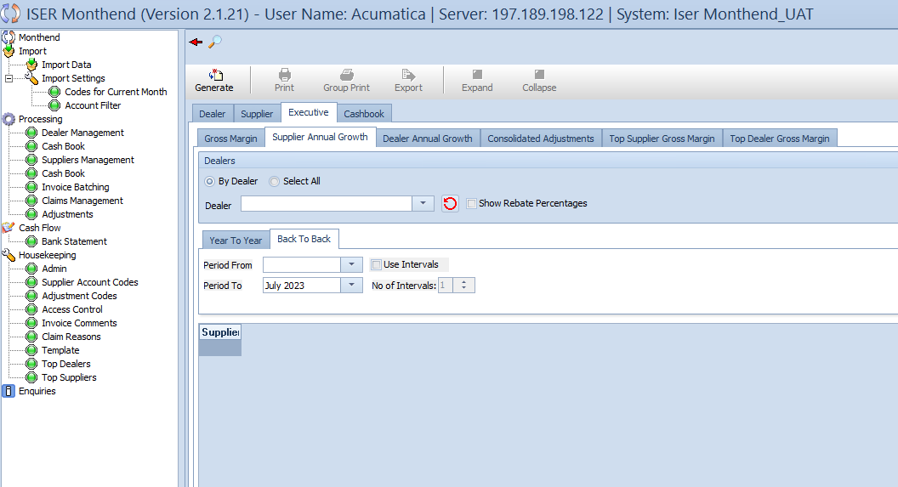

**Overview**

The “Supplier Annual Growth” sub-tab under the “Executive” tab in the “Enquiries” section serves as a vital tool for analyzing the annual growth of suppliers. Users can gain insights into performance metrics over specific periods, enabling strategic decision-making based on supplier dynamics. This view presents two distinct perspectives: “Year to Year” and “Back-to-Back”, each offering unique insights into supplier growth.

**Action Buttons**

Standard action buttons are available at the top of the view, allowing users to generate data, print, and export relevant information for further analysis.

**Dealers Grid**

The Dealers grid facilitates fine-tuning the analysis by selecting specific dealers and customizing the view based on user preferences. Components of the Dealers grid include:

* **Radio Group (Options: By Dealer, Select All):** Choose whether to view data by individual dealers or select all dealers.
* **Dealer Dropdown:** Select a specific dealer for a targeted analysis.
* **Refresh Button:** Update the view with the latest data based on the selected parameters.
* **Checkbox (Show Rebate Percentages):** Enable to display rebate percentages in the output table.

**Tabs – Year to Year and Back-to-Back**

The view presents two tabs, each offering a distinct perspective on supplier annual growth:

* **Year to Year Tab:** Users can select specific years and periods, with options to view totals only.
* **Back-to-back Tab:** Users can define periods, enable users intervals, and specify the number of intervals for a comprehensive analysis.

**Main Output Table – Suppliers Annual Growth**

* **Columns:**

1. **Supplier:** Name or designation of the supplier.
2. **Year:** The selected year for analysis.
3. **Period From and Period To:** The specified periods for growth comparison.
4. **Totals Only Checkbox:** Indicates whether the view displays totals only.
5. **User Intervals Checkbox:** Indicates whether user intervals are enabled.
6. **No Of Intervals (Back to Back Tab):** Specifies the number of intervals for back-to-back analysis.

**Interaction and Navigation**

Users can interact with the “Supplier Annual Growth” sub-tab by selecting specific dealers, defining periods, and customizing the analysis based on the chosen perspective (Year to Year or Back to Back). The output table provides a comprehensive overview of supplier growth, supporting users in strategic decision-making.

*Note: The “Supplier Annual Growth” sub-tab offers a versatile approach to analyzing supplier performance, allowing users to compare growth metrics over specific periods and gain valuable insights for informed decision-making.*

### 4.7.3 Dealer Annual Growth – Enquiries

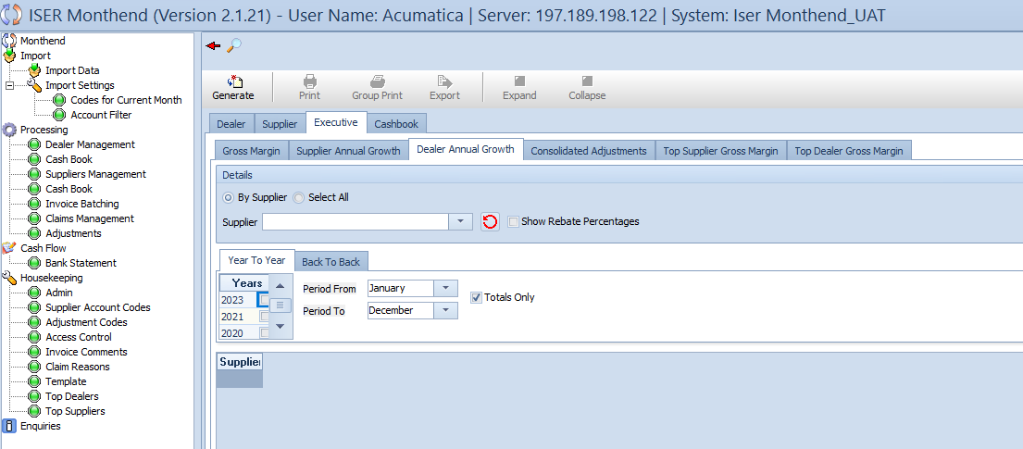

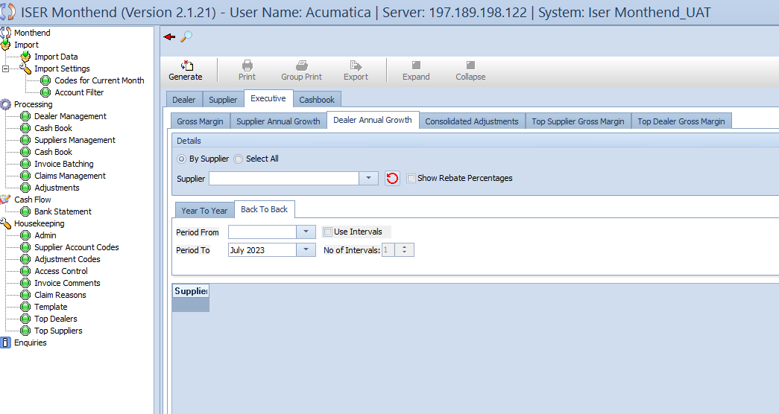

**Overview**

The “Dealer Annual Growth” sub-tab, nestled under the “Suppliers” tab within the “Enquiries” section, mirrors the structure of the “Suppliers Annual Growth”. This view provides a comprehensive analysis of annual growth for dealers, offering insights into performance metrics over specific periods. With a focus on flexibility and customization, users can delve into growth dynamics using the “Year to Year” and “Back to Back” perspectives.

**Action Buttons**

Familiar action buttons are available at the top of the view, empowering users to generate data, print, and export relevant information for in-depth analysis.

**Details Grid**

The Details grid retains its structure from the “Supplier Annual Growth” sub-tab, allowing users to tailor the analysis based on specific parameters. Components of the Details grid include:

* **Radio Group (Options: By Supplier, Select All):** Choose between viewing data by individual suppliers or selecting all suppliers.
* **Supplier Dropdown:** Select a specific supplier for a targeted analysis.
* **Refresh Button:** Update the view with the latest data based on selected parameters.
* **Checkbox (Show Rebate Percentages):** Optionally display rebate percentages in the output table.

**Tabs – Year to Year and Back to Back**

The view incorporates two tabs – “Year to Year” and “Back to Back”, each designed to offer unique insights into dealer annual growth. These tabs closely resemble their counterparts in the “Supplier Annual Growth” sub-tab.

* **Year to Year Tab:** Users can specify years and periods, with options to view totals only.
* **Back to Back Tab:** Users can define periods, enables users intervals, and set the number of intervals for a comprehensive analysis.

**Main Output Table – Dealer Annual Growth**

* **Columns:**

1. **Dealer:** Name or designation of the dealer.
2. **Year:** The selected year for the analysis.
3. **Period From and Period To:** Defined periods for growth comparison.
4. **Totals Only Checkbox:** Indicates whether the view displays totals only.
5. **User Intervals Checkbox:** Signals the inclusion of user intervals in the analysis.
6. **No Of Intervals (Back to Back Tab):** Specifies the number of intervals for back-to back analysis.

**Interaction and Navigation**

Similar to the “Supplier Annual Growth” sub-tab, users can interact with the “Dealer Annual Growth” sub-tab by selecting specific suppliers, defining periods, and customizing the analysis based on the chosen perspective (Year to Year or Back to Back). The output table provides a comprehensive overview of dealer growth, supporting users in strategic decision-making.

*Note: The “Dealer Annual Growth” sub-tab mirrors the structure of the “Supplier Annual Growth”, Offering a flexible and insightful approach to analyzing dealer performance over specific periods.*

### A screenshot of a computer4.7.4 Enquiries – Consolidated Adjustments

**Overview**

The “Consolidated Adjustments” sub-tab, housed within the “Executive” tab of the “Enquiries” section, serves as a pivotal tool for gaining insight into consolidated adjustments made by suppliers. This streamlined view offers a clear and concise presentation based on consolidated adjustment information.

**Action Buttons**

Familiar action buttons are positioned at the top of the view, providing users with essential functionalities, including data generation, printing, and exporting for external analysis.

**Main Output Table - Supplier Consolidated Adjustments**

* **Columns:**

1. **Date:** The date when the adjustment was made.
2. **User:** The user responsible for the adjustment.
3. **Supplier Ref:** Unique reference identifier for the supplier.
4. **Description:** A brief description of the adjustment.
5. **Amount:** The adjusted amount.
6. **Before Discount:** Original amount before adjustments.
7. **Discount Period:** Original amount before adjustments.
8. **Discount Period:** The Period associated with the adjustment.
9. **Code Ref:** Reference code linked to the adjustment.
10. **Remittance Group:** The group under which the adjustment falls.

**Interaction and Navigation**

The primary interaction in this sub-tab revolves around the supplier consolidated adjustments main output table. Users can leverage the action buttons for various operations, including data generation, printing, and exporting. The clear column structure of the output table facilitates a quick understanding of consolidated adjustments, empowering users to make data-driven decisions.

*Note: The “Consolidated Adjustments” sub-tab within the “Executive” tab streamlines the presentation of supplier adjustments, providing users with an efficient tool to grasp consolidated adjustment details and make informed decisions.*

### A screenshot of a computer4.7.5 Enquiries – Top Supplier Gross Margin

**Overview**

The “Top Supplier Gross Margin” sub-tab, nestled within the “Executive” tab of the “Enquiries” section, is a powerful tool designed for evaluating and understanding the gross margin performance of top suppliers. This view offers valuable insights into key metrics, allowing users to identify top-performing suppliers based on various parameters.

**Action Buttons**

Familiar action buttons at the top of the view enable users to perform essential tasks, such as data generation, printing, and exporting for external analysis.

**Details Grid**

The Details grid offers a user-friendly interface for refining data based on specific criteria. Users can select the desired period using From and To Period dropdown lists. Additionally, the Compare Additional Periods grid, featuring a checkbox for Add Period Comparison, allows users to make nuanced period comparisons for comprehensive analysis. An Only Show Top Dealers checkbox provides further customization options.

**Main Output Table – Top Supplier Gross Margin**

* **Columns:**

1. **Rank:** The ranking of suppliers based on gross margin performance.
2. **Supplier:** The name or identifier of the supplier.
3. **Turnover:** The total turnover attributed to the supplier.
4. **Discount Allowed:** Total discounts provided by the supplier.
5. **% (Discount Allowed):** Percentage of turnover represented by discounts allowed.
6. **Discount Received:** Total discounts received.
7. **% (Discount Received):** Percentage of turnover represented by discounts received.
8. **Net Discount:** Net discount calculated after adjustments.
9. **GM %:** Gross Margin percentage.
10. **Accrual:** Accrual amount.
11. **Accrual %:** Percentage of turnover represented by accrual.
12. **GM % After Accrual:** Gross margin percentage after considering accrual.

**Interaction and Navigation**

Users can interact with the “Top Supplier Gross Margin” sub-tab by utilizing the Details grid to customize period selections and apply additional comparisons. The main output table provides a comprehensive overview of top supplier gross margin metrics, allowing users to make informed decisions and identify key trends.

*Note: The “Top Supplier Gross Margin” sub-tab is a valuable resource for evaluating supplier performance, offering a user-friendly interface with detailed metrics to facilitate data-driven decision-making.*

### A screenshot of a computer4.7.6 Executive – Top Dealer Gross Margin

**Overview**

The “Top Dealer Gross Margin” sub-tab , situated within the “Executive” tab of the “Enquiries” section, mirrors the functionality of its supplier counterpart, offering a detailed analysis of the gross margin performance of top dealers. This view empowers users to assess and compare key metrics, facilitating informed decision-making and strategic planning.

**Action Buttons**

Common action buttons positioned at the top of the view streamline user interactions, enabling tasks such as data generation, printing, and export for external analysis.

**Details Grid**

The Details grid retains its user-friendly design, offering flexible data refinement options. Users can specify the desired period using From and To Period dropdown lists. The checkbox for Only Show Top Suppliers allows users to customize the view, focusing exclusively on top suppliers.

**Main Output Table – Top Dealer Gross Margin**

* **Columns:**

1. **Rank:** The ranking of dealers based on gross margin performance.
2. **Dealer:** The name or identifier of the dealer.
3. **Turnover:** The total turnover attributed to the dealer.
4. **Discount Allowed:** Total discounts provided by the dealer.
5. **% (Discount Allowed:** Percentage of turnover represented by discounts allowed.
6. **Discounts Received:** Total discounts received by the dealer.
7. **% (Discount Received):** Percentage of turnover represented by discounts received.
8. **Net Discount:** Net discount calculated after adjustments.
9. **GM %:** Gross margin percentage for the dealer.
10. **Accrual:** Accrual amount attributed to the dealer.
11. **Accrual %:** Percentage of turnover represented by accrual for the dealer.
12. **GM % After Accrual:** Gross margin percentage after considering accrual for the dealer.

**Interaction and Navigation**

Users can interact with the “Top Dealer Gross Margin” sub-tab using the Details grid to customize period selections and apply additional comparisons. The main output table provides a comprehensive snapshot of top dealer gross margin metrics, empowering users with actionable insights for strategic decision-making.

*Note: The “Top Dealer Gross Margin” sub-tab is a valuable tool for assessing and comparing dealer performance, featuring a user-friendly interface and detailed metrics to support data-driven decision-making.*

### A screenshot of a computer4.8.1 Enquiries – Cashbook - Debtors

**Overview**

The “Cashbook” tab within the “Enquiries” section provides a comprehensive insight into financial transactions, covering areas such as Debtors, Remittance Not Submitted, and Cashbook Not Processed. Each sub-tab offers specific details and metrics to aid in financial analysis and decision making.

**Action Buttons**

Common action buttons at the top of each sub-tab facilitate user interaction, including data generation, printing, and export functionalities.

**Navigation Controls**

Standard navigation controls ensure seamless access to different sub-tab within the “Cashbook” tab, allowing users to navigate effortlessly through diverse financial data.

**Debtors Sub-Tab**

**Overs and Unders View:**

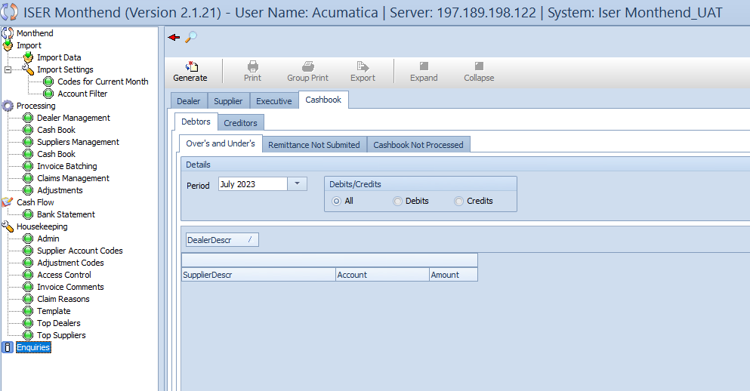

* **Details Grid:**

1. **Period Dropdown:** Select the month for financial analysis.
2. **Radio Group –** **Debits/Credits:** Options include All, Debits, and Credits.

* **Main Output Table:**

1. **Columns:** SupplierDescr, Account, and Amount.

**Remittance Not Submitted View:**

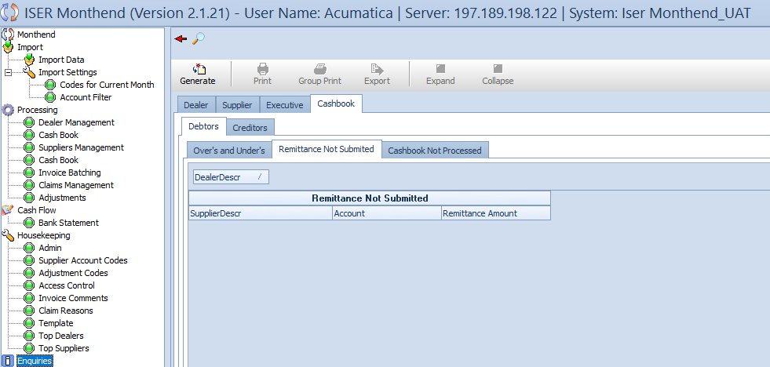

* **Main Output Table:**

1. **Columns:** SupplierDesc, Account, Remittance Account.

**Cashbook Not Processed View:**

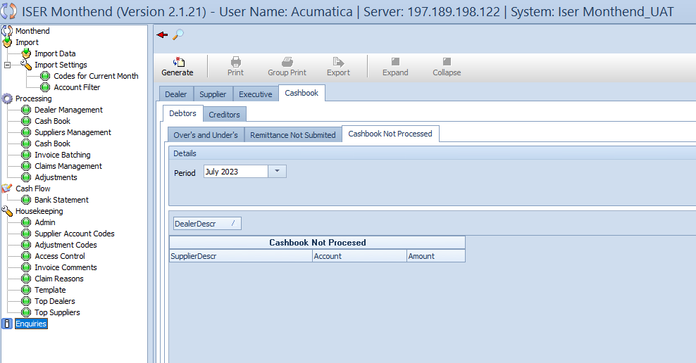

* **Details Grid:**

1. **Period Dropdown:** Choose the month for analysis.

* **Main Output Table:**

1. **Columns:** SupplierDescr, Account, and Amount.

**Interaction and Navigation**

Users can leverage the Details grid in each sub-tab to customize the period and refine data based on specific data based on specific criteria. The main output tables offer a clear presentation of financial details, empowering users to identify trends and discrepancies. Standard action buttons and navigation controls enhance the overall user experience.

*Note: The “Cashbook” tab is a valuable resource for financial analysis, providing insights into debtors, remittances, and unprocessed cashbook entries. Users can efficiently navigate through different views to gain a comprehensive understanding of financial transactions.*

### 4.8.2 Enquiries – Cashbook – Creditors

**Creditors Sub-Tab**

**Supplier Discount Received View:**

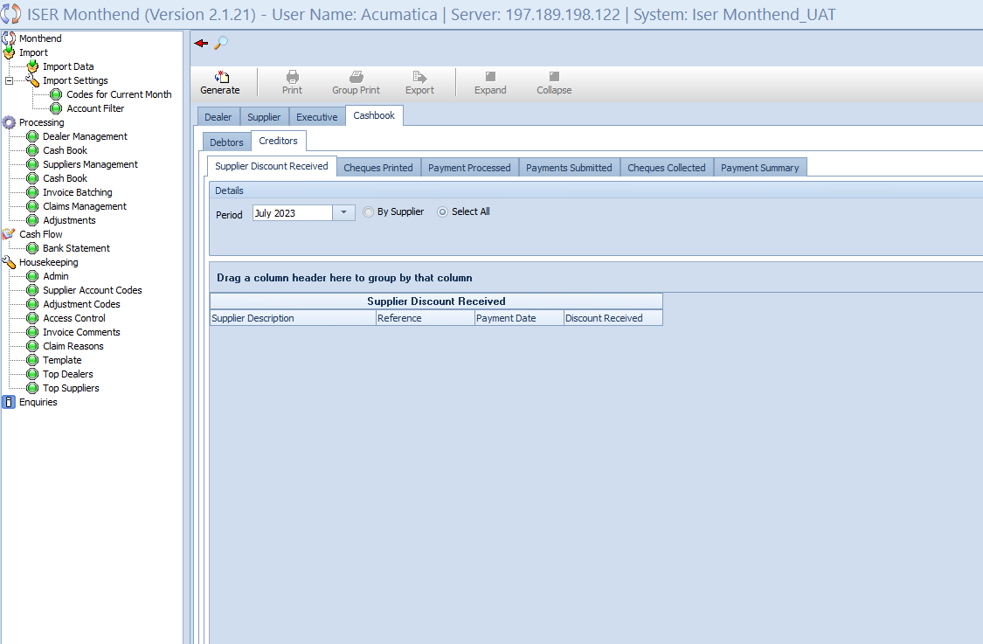

* **Details Grid:**

1. **Period Dropdown:** Allows users to specify the month for analysis.
2. **Radio Group Options:** By Supplier and Select All.
3. **Output Table (Supplier Discount Received):**
   * + **Supplier Description:** Details about the supplier associated with the transaction.
     + **Reference:** Reference information for the transaction.
     + **Payment Date:** Date when the payment was made.
     + **Discount Received:** Amount received as a discount.

**Cheques Printed View**

* **Details Grid:**

1. **Dropdown List (Period):** Allows users to select the desired period.

* **Output Table (Cheques Printed) Columns:**
  + - **Supplier Description:** Description of the supplier.
    - **Payment Method:** Method used for payment.
    - **Print Date:** Date when the cheque was printed.
    - **Status:** Status of the cheque (e.g. pending, Processed).
    - **Cheque Number:** Unique identifier for the cheque.
    - **Amount:** Amount mentioned in the cheque.
    - **Note:** Additional notes related to the cheque.

**Payment Processed View:**

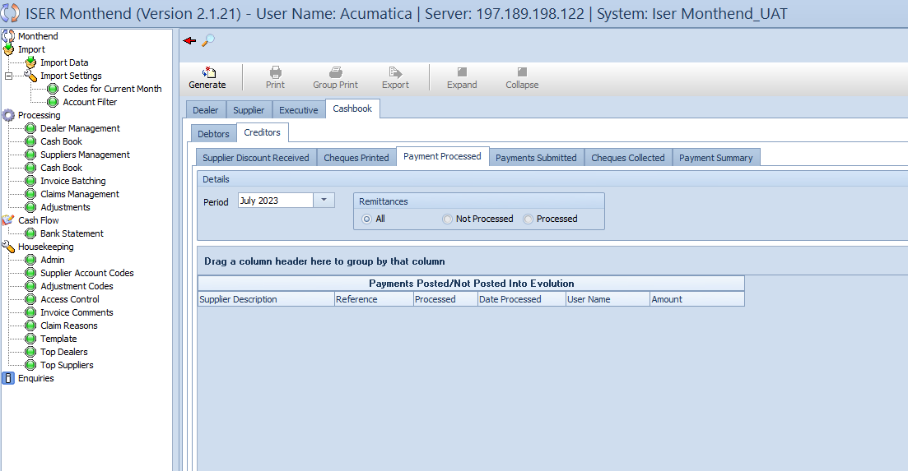

* **Details Grid:**

1. **Period Dropdown:** Allows users to specify the month for analysis.
2. **Radio Group (Remittances) Options:**
   * + **All, Not Processed, Processed.**
3. **Output Table (Payments Posted/Not Posted Into Evolution) Columns:** 
   * + **Supplier Description:** Description of the supplier.
     + **Reference:** Reference information for the transaction.
     + **Processed:** Indicates whether the payment is processed or not.
     + **Date Processed:** Date when the payment was processed.
     + **User Name:** Name of the user involved in the processing.
     + **Amount:** Amount of the transaction.

**Payments Submitted View:**

* **Details Grid:**

1. **Period Dropdown:** Allows users to select the desired period.

* **Output Table (Payments Submitted for Remittances) Columns:**
  + - **Supplier Description:** Description of the supplier
    - **Reference:** Reference information for the transaction.
    - **Submitted:** Indicates whether the payment is submitted.
    - **User Name:** Name of the user who submitted the payment.
    - **Date Submitted:** Date when the payment was submitted.
    - **Amount:** Amount of the transaction.

**Cheques Collected View:**

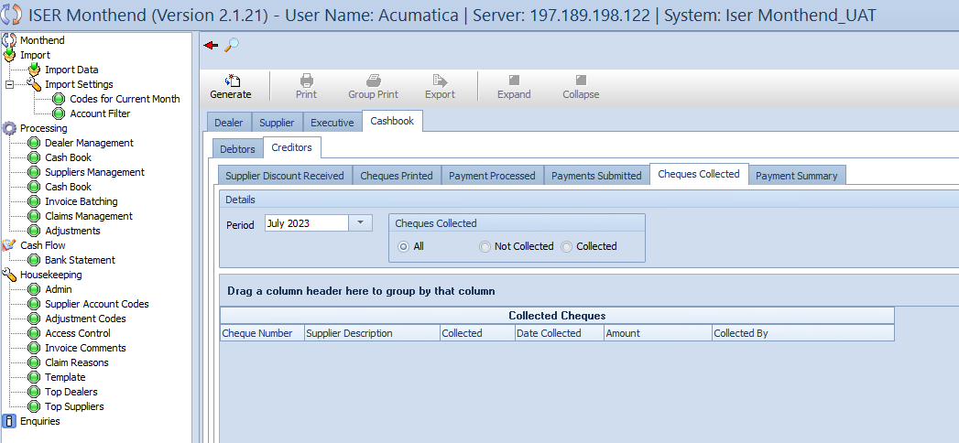

* **Details Grid:**

1. **Period Dropdown:** Allows users to specify the month for analysis.
2. **Cheques Collected Radio Group Options:** 
   * + **All**
     + **Not Collected**
     + **Collected**
3. **Output Table Columns (Collected Cheques):**
   * + **Cheque Number:** Unique identifier for the cheque.
     + **Supplier Description:** Description of the supplier.
     + **Collected:** Indicates whether the cheque is collected or not.
     + **Date Collected:** Date when the cheque was collected.
     + **Amount:** Amount mentioned in the cheque.
     + **Collected By:** Indicates the person who collected the cheque.

**Payment Summary View:**

* **Details Grid:**

1. **Period Dropdown:** Allows users to specify the month for analysis.
2. **Show Remittance Groups Checkbox:** Enables users to display remittance groups for detailed insights.
3. **Remittance Options Grid:**
   * + **Select All Checkbox:** Facilitates the selection of all remittance options for comprehensive data representation.
4. **Output Table Columns:**
   * + **Remittance Group:** Categorizes payments under specific remittance groups.
     + **Supplier Description:** Provides details about the supplier associated with the payment.
     + **Rebate:** Indicates the rebate amount.
     + **Controller:** Specifies the controller overseeing the transaction.
     + **Total:** Represents the overall sum of the transaction.
     + **Adjustment Before:** Displays the adjustments made before the transaction.
     + **Unclaimed Deducted (UCN):** Shows the amount deducted as unclaimed.
     + **Unclaimed Paid Back (URCN):** Displays the amount paid back for unclaimed deductions.
     + **Gross:** Represents the gross amount involved in the transaction.
     + **Discount:** Indicates the discount applied.
     + **Annual Rebates Taken (EBD):** Reflects annual rebates paid back.
     + **Annual Rebates Paid Back:** Displays annual rebates paid back.
     + **Extra Discount Taken (DSCD):** Indicates the amount paid back for discounts.
     + **Discount Paid Back** **(DSCP):** Indicates the amount paid back for discounts.
     + **Early Settlement Paid Over (ERLS):** Displays amounts paid over for early settlements.
     + **Early Settlement Discount Taken (ESTD):** Represents early settlement discounts taken.
     + **ISER Price Protection Claimed (IPPC):** Reflects ISER price protection claims claimed.
     + **ISER Promotional Claim Paid Back (IPRO):** Indicates ISER advertising claims taken.
     + **ISER Advertising Claims Taken (IADV):** Represents ISER advertising claims taken.
     + **ISER Advertising Claim Paid Back (IADP):** Displays ISER advertising claims paid back.
     + **ISER Show Deducted (ISSH):** Shows amounts deducted for ISER shows.
     + **ISER Show Paid Back (ISSP):** Indicates amounts paid back for ISER shows.
     + **ISER Promotional Claims Taken (IPCT):** Reflects ISER promotional claims taken.
     + **ISER Promotional Claims Paid Back (IPCP):** Displays ISER promotional claims paid back.
     + **Discount Previously Short Deducted (SDSD):** Represents discounts previously short deducted.
     + **SPIVS Paid Back (SPIP):** Indicates SPIVs paid back.
     + **SPIVs Taken (SPIT):** Reflects SPIVs taken.
     + **Dealer SPIVs Taken (DSPIV):** Displays SPIVs taken by dealers.
     + **Annual Rebate:** Represents the annual rebate amount.
     + **Adjustment After:** Indicates adjustments made after the transaction.
     + **Nett:** Displays the net amount.
     + **Payment Reference:** Specifies the reference associated with the payment.

*Note: The “Creditors” sub-tab provides a comprehensive overview of various aspects of creditor transactions, including details about discounts, cheques, payments, and remittance summaries. The inclusion of multiple views with distinct details enhances the user’s ability to analyze and manage creditor-related financial data. Standard action buttons and navigation controls ensure ease of use within the “Cashbook” tab of the “Enquiries” section.*